Basketball Key Stage 3 Scheme of Work

Aims: In this unit pupils focus on acquiring the skills to effectively demonstrate competence in the game of basketball. An understanding of tactics and strategies used in isolation for attacking and defending will also be discussed to assist students in their decision making. Students are expected to demonstrate progress and evidence this in their KS3 booklets. Attacking and defensive principles will be explored and studnets will be given the opportunity to develop their own ideas based on prior learning.

PRIOR LEARNING  It is helpful if the pupils have:  - Experienced setting up and organising basketball practices in groups  - Applied and adapted the principles of attack and defence in small sided games  - Lead own warm up and cool down safely.  - Learnt about specific techniques  Used and applied basketball rules fairly and correctly. | LANGUAGE FOR LEARNING/ICT/CITIZENSHIP  Through the activities in this unit pupils will be able to understand, use and spell correctly word relating to basketball . Example principles of attack and defence, marking, covering and following through.  Opportunities for pupils to record rules and tactics using ICT. Watch video/compare professional game  Communication Speaking and Listening  Cooperation Working together | RESOURCES  - Basketballs  - Bibs  - Cones  - Access to information through ICT  - Information on local clubs
Key Concepts and Processes:
Outwitting an opponent:  Pupils will continue to develop the ability to outwit opponents and teams using strategies and tactics. Pupils will learn to combine and perform more advanced basketball skills consistently applying accuracy and high quality replication of technique. Continual development and refinement of skills will contribute to producing an improved performance & technique. | Developing Physical and Mental Capacity  Physical warm ups aid as a useful fitness tool in developing a pupils physical capacity. Develop a knowledge of the major rules and laws involved in Basketball. Use basketball to develop observation skills on peer performances, skills and techniques. Ask questions about the effectiveness of these tactics. | Developing Skills/Performance  Pupils will further develop the fundamental principles of play when selecting and applying tactics for defending and attacking. Passing, Receiving, outwitting defenders, Dribbling, and shooting will be developed through small sided games and conditional situations. Demonstrating high quality performances and accurate replication will be assessed.

Making and Applying Decisions  Pupils will be constantly faced with strategic and tactical decisions based on movement of the ball into space and choice of skill execution. Opportunities to referee/coach pupils or small groups will develop communication and decision making skills. Opportunities to referee/coach pupils or small groups will develop communication and decision making skills.. | Making Informed Choices About Healthy, Active Lifestyle  Develop a deeper understanding of stretches for all major muscle groups and those specific to basketball. Suggest any basketball clubs within the school timetable and promote community links. Discuss the benefits of being healthy and living an active lifestyle both at school and post 16. |  | Evaluating and Improving  Be able to understand the concept of basketball and make effective evaluations of strengths and weaknesses of performance. Appropriate questioning on teaching points of the skills and processes developed. Observation and peer assessment. Pupils will develop capacity to self-assess, assess others and to coach.
Cross Curricular Links: Literacy (key words), Maths (scoring), Citizenship (sportsmanship), Science (bodily functions and healthy lifestyle consequences) |  | Assessment: Q & A, Formative and summative assessment. Video analysis, notational analysis, touch maps

Student Outcomes  Level 5 students: experiment with a range of basic tactics, searching for strengths and weaknesses in the opposition, and form a simple game plan; can select and apply basic skills such as passing with shooting in order to achieve particular outcomes; understand why regular exercise has a positive effect on their own health, fitness and social wellbeing and know where and how to become involved in regular physical exercise; use information gained from feedback to improve performance in game contexts and in personal technique; contribute effectively to team decisions, can office with support.  Level 6 – students: make observations about the quality of decision making in modified versions of the full game and offer suggestions for improvement; show some consistency and accuracy in using a range of passing techniques, to include skip, chest and javelin linked to footwork. Students can lead in discussions about team tactics, without support; work effectively with a partner, and umpire using the key rules in a game; take regular exercise and understands the components of fitness required in basketball, able to formulate a game plans based on observation and on the strengths and weaknesses of the opposition and their own team; identify strengths and weaknesses in individual performance. | Level 7+ – students:  demonstrate consistency and accuracy in their decision making and appropriate choice of technique for all desired outcomes in every aspects of the game; use a wide range of advanced skills and techniques with precision, power and fluency (lay-up, set shot, jump shot) Uses a range of tactics to implement a game plan effectively in both offense and defense; able to identify and priorities aspects for improvement; can design and implement practices and exercises to improve performance; can coach another player and select the focus for development of technique; is conversant with a variety of analytical tools to provide quality feedback on a performance. Can organise and umpire a game / tournament. Able to plat in a number of positions effectively. Demonstrates competence in all roles as a performer, official and leader in both singles and doubles.
Learning Experiences across the key stage

Year 7: Objectives:

- To explore the fundamentals of basketball, looking at handling skills, including passing & receiving, dribbling in isolation and under pressure. To be able to perform these in a small sided game to maintain ball possession. To develop their understanding and application of the basic rules of Basketball. DS & DM
- To be able to outwit opponents with passes and angled runs. To understand the need for tactical movements (cuts) to invade opponents space. To develop their DM skills based upon the situations they find themselves. 3v3 scenarios, played as netball. Ie no dribbling. DS & DM
- Explore footwork and highlight the importance; linked to receiving and preparing the shot / pass. (Triple threat position, pistols, pivoting)
Small sided games, no dribbling to reinforce effective movement and shot preparation. ½ ct games. DS
- To develop their understanding and knowledge of how to execute a successful set shot. To be able to outwit opponents using fake and disguise in the execution of such a skill. To evaluate their S&W in the execution of the skill. DS & E&I
- To perform a basic lay up technique appreciating the outcome necessary. To develop their understanding and knowledge of how to outwit an opponent using appropriate shot selection. To understand and appreciate the need to make decisions about choice of technique and refining ideas when unsuccessful. Recognize similarities and differences between the 2 shots. DS & E&I
- ½ court competition 3 v 3. Look at application of the rules and the signals form the officials. Conditioned games where defence can only operate inside the key.
- Continuation of ½ court games to include the principles of man 2 man defence. Round robin tournament differentiating courts on ability. Create an additional team that ensures each person officiates.
- Competition. Discuss tactics in relation to attack of defense. DM.

Year 8 Objectives:

- ½ court games to recap the rules of basketball. 2 v 2 with 2 officials where appropriate. Focus of lesson being on everyone recapping their understanding of the rules in a competitive format. All students to rotate and officiate on a carousel. To set targets to develop key areas across the unit of work (APP)
- To explore different attacking techniques in isolation and also as a unit to OWO. These are to include screening, boxing out and fake & drive, 1-2., 2v2 To analyse the effectiveness of such techniques and build in to our play.
- Continuation of attacking strategies as in lesson 2. Use notational analysis cards to capture the evidence for the successful execution of the attacking strategies. Evaluate WWW & EBI. Use of booklets to capture progress and set targets against the wheel.
- Development of students understanding of screening. The different types of screens available and measure the effectiveness in a game. ½ court conditioned games where the scores must move off a screen before the basket becomes active. DM & E&I
- Revisit the techniques involved in shooting. Examine the similarities between the lay-up and set shot. Develop the technique in both isolation and also under pressure in 2v2 situations. DS.
- Develop student’s awareness of closing out further in 2v2 7 4v4 settings. Ensuring that the floor space is appropriate between A and D dependent upon who is marking the ball and who isn’t. Communication and body position to be a focus.
- Round robin competition. Students to demonstrate the knowledge of the rules, their technique under pressure and also their effectiveness in the execution of their strategy in attack and defense. Officiating the focus.

Year 9 Objectives:

- Closing out as a concept. Both for the ball carrier and off the ball. Link to footwork, pistols technique. 2 v2 from the base line. Closing out the attack. Rotate roles when there is a turn over. Evaluate the effectiveness of the defence, denying space and thinking time.
- Continuation of closing out, develop the concept to 3v3 and 4v4. Positional play, cover defence should be highlighted. Change the point of attack now from side lines and base line plays.
- Look at base line and side line plays. A stack could be used from the base line. Students are to create their own tactics from either line and rehearse them to develop consistency and accuracy.
- Full court games to explore strategies for attacking and defending. Fast break to be rehearsed in isolation and then the principles to be demonstrated in a game. Look at when, how and why the fast break is used.
- Explore motion offense, and look to devise strategies that will change the point of attack, set screens and get the shot away in full court games. The strong side and weak side should be discussed.
- Full court defence – to include man 2 man defence and zonal marking. Look at the strengths and weaknesses in each. 2 hustlers, 2 traps, and a safety, Look at the effectiveness of this and how and why you should default back to a zone.
- Look at different types of zonal defence, 3-2, 2-1-2, 1-4. Students to recognize how to set them up, why they would set the up and how to link them to a fast break.
- Officiating a competition. Students to organize an order of play, teams and office a competition.

Language for learning
Through the activities in this unit pupils will be able to understand, use and spell correctly words relating to:
• tactics, eg principles of attack and defence, finding and using space, changing speed, being direct, marking, covering, delaying, moving feet, watching the ball, following through
• preparation, eg warming up, cooling down
• assessment, eg collecting and analysing data, reflecting on their own performance identifying areas for development.
Speaking and listening – through the activities pupils could:
• collaborate with others to share information and ideas, and solve problems
Extension & Enrichment
Out of lessons, at home and in the community, pupils could be encouraged to:
• practise skills at home
• take part in school sport, either competitively or socially
• join clubs in the community and/or use local facilities
• watch live and recorded matches, to appreciate high-quality performance
• make up games that focus on improving technique and fitness
• read rule books and sports reports in newspapers and magazines

WEEK | LEARNING OBJECTIVES | TASK EXAMPLES | POINTS TO NOTE/  DIFFERENTIATION
1 | Ball familiarization  Objectives  - To develop fundamental ball handling skills, including passing & receiving in isolation and under pressure.  - be able to perform these in a small sided game to maintain ball possession. To develop their understanding and knowledge of the basic rules of Basketball.  - Discuss double dribble and travelling  Teaching points: for shoulder, chest, skip pass discussed;  Receiving one or two handed. Link to footwork & triple threat.  Attacking and defensive dribbling discussed briefly.  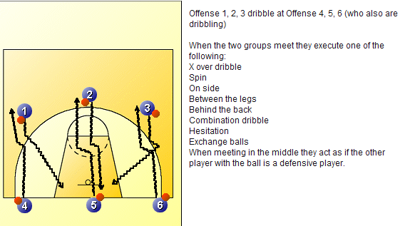 | Warm up – Student led, progressive jogging and dynamic stretching.  Handling skills. (Move ball around back, head, legs, figure of 8). Catching ball from partner. Basic dribbling + movement around court in pairs passing + receiving, must pivot when got ball.  All students have a ball and dribble freely across 1 basketball court. On the whistle students may try to knock away another students ball. Discuss the differences between attacking and defensive dribbling and when and why they would be appropriate.  Progressions -  In a badminton service box go 1v1 one ball only. Under pressure number 1 attempts to retain possession for 30 seconds, number 2 attempts to steal without making contact. Discuss ways in which to OWO in either attack or defence.  Progress to 2 v 2 across 2 service boxes. Look at adopting the triple threat upon receipt of ball and fronting your man. Again discuss the technical and tactical advantages of this in a game.  Final progression 4 v 4 full badminton court. Baskets scored when the ball is moved successfully across all thirds and back again.  Plenary – discuss the importance of protecting the ball, the triple threat and the technical points of passing and receiving. Where are their S&W and how can they develop them. | All lessons start with basketball related warm-up and re-cap work of previous lesson.  Make learning as active as possible  Give opportunities to plan tactics  Research rules on internet  Video to analyse performance  Tasks set to cater for levels of ability:  Distance from target  Size of practice area
2 | Passing, receiving and outwitting an opponent.  Objectives  - To introduce & understand where passing is used in basketball. To be able to outwit opponents with passes and angled runs.  - To begin to understand the need of tactical movements to invade opponents space.  - To develop their DM skills based upon the situations they find themselves.  - Teaching points: for each style of pass discussed and demonstrated. Students need to be challenged on their ability to make effective decisions based on the information in front of them.  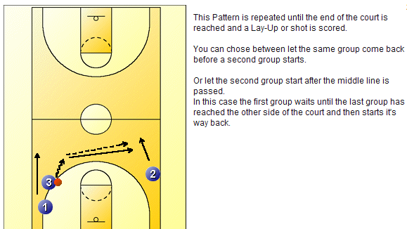  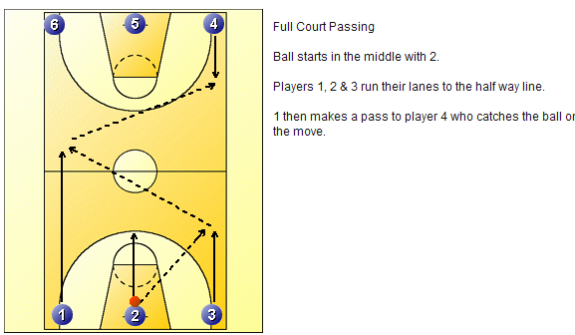 | In pairs, pass & move into space. Receive the ball in 2 hands and pivot forward and reverse and then pass to partner who has moved into space. Use the whole sports hall with the group if possible. 3 man weave could be used as an extension of the warm up to get students use to passing and moving.  Recap on last lesson – start with 2v 2 in a third of a badminton court and look to retain possession, no overhead pass at this stage. Chest and skip only. Change roles. Discuss the use of effective body positioning, protecting the ball and good footwork to set the platform for the pass.  Progress to 2 v 1 in half a badminton court & 1 official. Piggy in the middle, still no overhead pass allowed. Official to look for travel / contact fouls. As groups are now in 4’s – play 3 v3 around the key. 5compeleted passes equals a free shot from the penalty line, 1 official from either team looking for travel and contact. Rotate accordingly. No dribbling allowed at this stage.  Progress – 1 person allowed to dribble but the pass to and from him do not count. Discuss with the students why and when you would dribble? Reinforce the rules of possession, 5 seconds. Travel and double dribble.  Show effective movement to support player with the ball.  Develop into conditioned basketball game – 3 passes before you can score. Plenary - discuss the importance of effective movement, communication and the tactics deployed in their small sided game. Where are their S&W and how can they develop them.  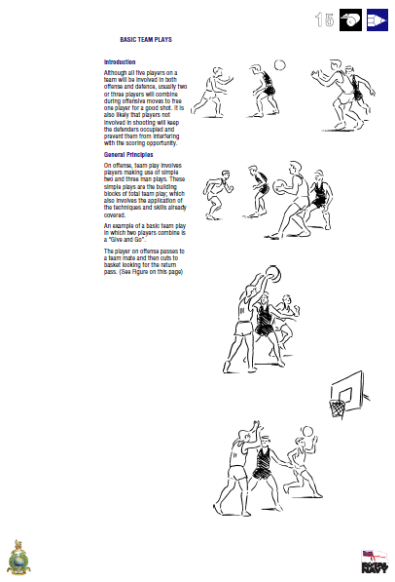
3 | Footwork  Objectives –  - To develop students understanding of effective footwork in basketball.  - To discuss techniques such as the triple threat, forward and reverse pivoting & pistols  - Pistols technique in defense either for the man on the ball or off the ball.  - Landing 2 footed or 1-2 landing. Advantages and disadvantages.  To be able to perform the basic dribbling technique with control and accuracy. To be able to outwit opponents with the use of these skills. To be able to perform skills in a small sided game making decisions about how best to advance on opposition. To develop an understanding of the rule of travelling in Basketball.  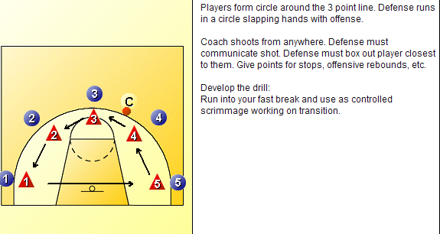  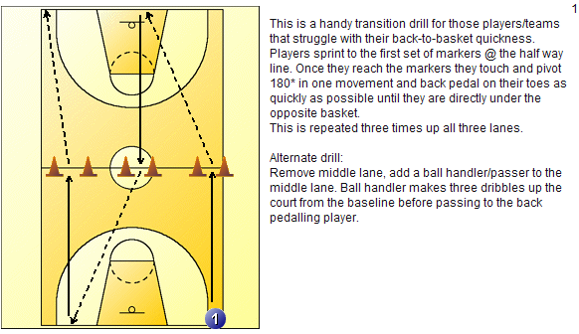 | Students to initially in isolation tap alternate feet, on the command of shot, pivot and perform a jump shot. The technique of shooting in isolation should be discussed. The shooting foot should be identified.  Progress to Students being introduced to the jab step and in a 1v1 situation they need to try and outwit one another by creating the time and space to get the shot away. This could also be progressed to including the dribble and then the lay-up.  Rotate rolls and identify what the strengths and weaknesses in their own performance were.  Defensive stance and ensuring that the weight is on the balls of the feet of the defender is key to maintain an effective athletic stance.  Students to play 2v2 around the key. Attackers to include a job step & triple threat and the defenders to concentrate on pistols and the pivoting to box out the opposition after the shot has gone up.
4 | Intro Shooting – set shot  - To develop their understanding and knowledge of how to execute a successful set shot.  -To be able to outwit opponents using fake and disguise in the execution of such a skill  - To evaluate their S&W in the execution of the skill  Students need to understand the essential T.P’s.  Perform set shot technique on the spot (BEEF- bend legs, elbows-45º, eyes on ring & follow through-snap wrists).  3’s Shoot at basket – from free throw line.  Jab step – shooting foot used to get the defender to put their weight on their back foot.  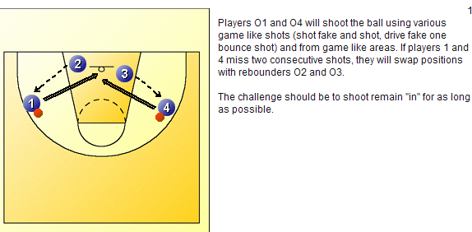 | Killer can be used to organize their learning after they have warmed –up. Teacher demonstration and use of ICT will reinforce the movement pattern.  Discuss the differences in the technique of the arm action of both shots? 3 v 3Netball game, when the pass is successfully completed in the key an unopposed shot is allowed. Thereafter the ball is live when it has left his hand. Any turn over a restart from the half way line – defenders must always start inside the 3 point line.  Progression – 3v3 one defender can leave the key to ensure that the game has intensity and pressure is applied to the ball. Reinforce prior learning of defensive footwork both on and off the ball.  Introduce an official who is looking for travel, double dribble and the 3 second rule.  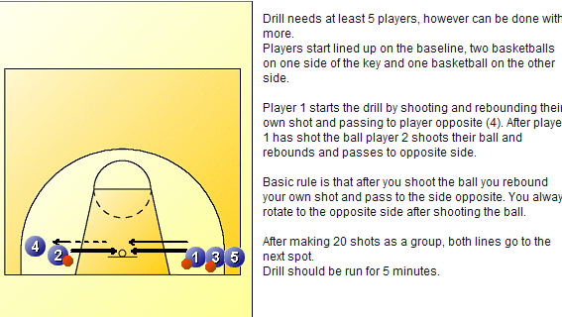

5 | Shooting – lay up  - To perform a basic lay up technique appreciating the outcome necessary.  - To develop their understanding and knowledge of how to outwit an opponent using appropriate shot selection.  - To understand and appreciate the need to make decisions about choice of technique and refining ideas when unsuccessful.  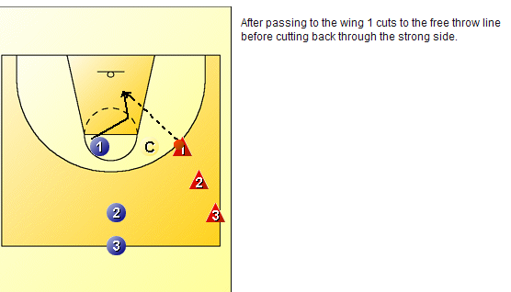  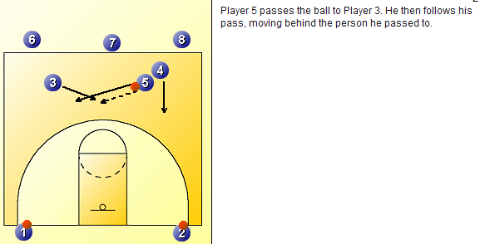 |  | In groups of 4 – 2 either side, practice both sides. Can progress to some defensive pressure. 2v2 ½ court trying to outwit opponents using skills built up. Highlight importance of ball support, width/angles, moving the ball quickly.  Teaching points; Footwork, Approach-45º to basket, Aim for square, Attack at pace/drive to basket.  Small Sided Game-3v3 games full court.  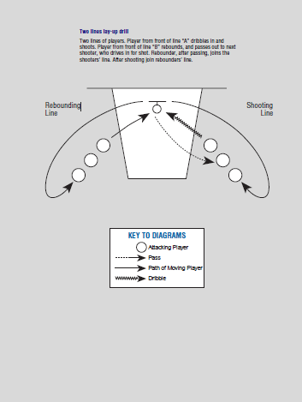
6 | Application of skills and rules.  Objectives  - To develop students understanding of tactics and strategies in small sided games  - Apply the basic rules of competition and provide the relevant signals to inform others  3 v 3 tournament – Each team will be given the opportunity to apply all the skills learnt and also apply their understanding of the rules through being given the opportunity to officiate. The inclusion of white boards / laminated courts will allow students to plan their tactics before going on court. Students will gain / loose points depending on the outcome of the shot. This is to reduce impulse shooting and ensuring students maintain possession prior to getting the shot away. Adopt a round robin format and after every second game discuss some match analysis to reinforce AFL & APP opportunities. At the end of the lesson involve students in identifying what level they are working at and more importantly set targets for further development.  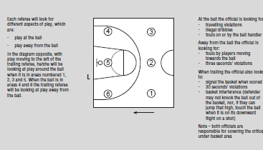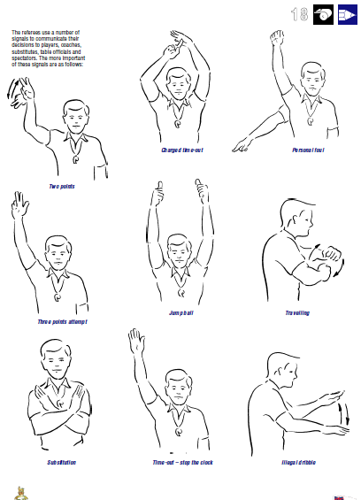
WEEK | LEARNING OBJECTIVES | TASK EXAMPLES
1 & 2 | Recap on the Fundamental covered in Year 8  Objectives  - To be able to perform a variety of passing and receiving, dribbling and shooting techniques in isolation and also under pressure (3v3)  - To set targets to develop key areas across the unit of work (APP) | Warm up – Student led, progressive jogging and dynamic stretching.  Starter – dribble, ball steal, emphasise the importance of protecting the ball first and foremost.  Recap basic techniques- handling skills, passing + receiving effectively. Pupils investigate the best ways of passing to attack.  Pupils develop analytical skills in reference to the perfect model and profile their own performance.  Students will complete a player profile sheet in order to analyse themselves and then their peers can grade their outcomes on the reverse; consequently targets will be set for the unit.  3v3 attack and defence. Students to retain possession and work the opportunity to attack the basket for a lay-up. If the attacking team wins the rebound, play on. If the defense wins it the attacking team must return to the center to start a fresh attack. 3 minutes of continuous attack and defense.  Come together to discuss how effective the attacking team where, how they could develop their play. Rotate roles.  Progression – immediate turn-over / then high / low percentage shot to encourage attacking the rebound on the low percentage shot.  Plenary – discuss how effective the strategies were, and individually how each student can develop their practice. |  | All lessons start with basketball related warm-up and re-cap work of previous lesson.  Make learning as active as possible  Give opportunities to plan tactics  Research rules on internet  Video to analyse
3 & 4 | Attacking and outwitting an opponent.  Todays objectives  - To explore different attacking techniques in isolation and also as a unit to OWO. These are to include screening, boxing out and fake & drive, 1-2., 2v2  - To analyse the effectiveness of such techniques and build in to our play.  - To identify strengths and areas for development as an individual and also as part of a team.  Fundamentals of the Person Receiving the Screen  Set up the defender - It's very important for the offensive player to set up the screen. First of all, (s)he needs to wait until the screener is completely set. If (s)he leaves too early while the screener is moving, the screener will get called for an offensive foul.  Second, it's very good to set up the screen by faking the opposite direction even if it's only a slight head fake. This will get the defender leaning in the wrong direction and when he explodes the other direction to catch up with you, he'll run hard into the screen.  Shoulder to Shoulder - When running off the screen, you will need to run shoulder to shoulder. This will not give the defender any room to get around the screen. It will force him to either trail behind you or plow through the screener for a defensive foul. | Warm up basic skills.Warm up – Student led, progressive jogging and dynamic stretching. Starter – dribble, ball steal, emphasise the importance of protecting the ball first and foremost  1v1 –explore ways to get from AtoB?  Then demonstrate the Jab Step and contextualize its importance in wrong footing a defender and also buy time and space to create time to shot or pass.  Then progress to 1v1 to the basket. 1 minute each, recognize good use of the step as a technique; however it does not always need to be used.  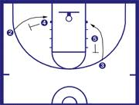  Fundamentals of the Screener (Person setting the screen):  Feet should be a little wider than shoulder-width apart. It's very important to have a wide, strong base. Hands should be crossed across your chest (girls) or protecting your groin area (boys)  The screener needs to be stationary as the screen is set. Otherwise, the screener will be called for a offensive foul. Body should be vertical (should not be leaning forward or backwards).  Square to the defender. The middle of the screener's chest should be in line with the defender's shoulder and hips.  After the offensive player has ran off the screen, it is very important to open up to the basketball. Normally, you will pivot 180 degrees to the basketball. Sometimes, a cut to the basket or away from the basket may be open. Many times, the screener is the person who is open.
 | Down Screen - A player runs toward the baseline closest to their basketbal goal to set a screen. In the next two diagrams, we have examples of down screens.  In this diagram, Player 1 starts from the three point line and runs to the block area to set a down screen for Player 2.  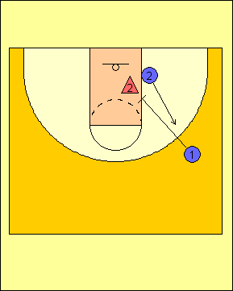  In this diagram, Player 1 starts from the high post area to set a down screen for Player 2. | Ball Screen - A ball screen is when an offensive player sets a screen for another offensive player who currently has the ball in possession. The only time you will want to set a ball screen is when the offensive player still has his or her dribble.  In this diagram, Player 1 is at the top of the key and Player 2 runs from the wing to set a ball screen on the defender guarding Player 1  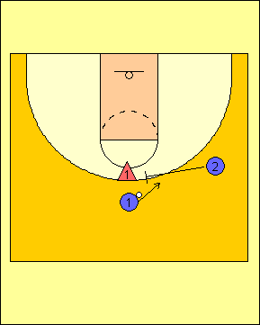  Back Screen - A back pick occurs when the screener sets a screen away from the ball on the defender's back. It may also be called a "Blind Screen" as well. Legally, the screener is suppose to give the defender one step, otherwise, the screener may be called for an offensive foul.  In this diagram, Player 2 comes from the block area to set a back screen for Player 1 near the three point line.  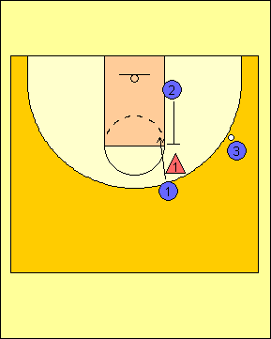
5 & 6 | Objectives  - To explore the different techniques required for shooting under different conditions  - To understand the similarities and differences used across techniques  - To understand how, when and why one technique maybe more appropriate than another  - To develop an understanding of the importance of width and playing into space in order to attack.  Recap Shooting –lay up  When dribbling toward the basket, move slightly to one side of the hoop to create the proper angle. If you're on the right side, dribble right-handed, and plant your left (inside) foot and jump off that foot, and finally shoot with your right hand. As you raise your right hand, your right knee should also elevate. Pretend there is a string attached to your right hand and your right knee. Reverse this form if shooting from the left side.As you approach the hoop, take a half step with your outside foot, then take a full stride with your inside foot pushing off the court. When jumping your outside knee should be bent. Go directly toward the basket, with your head up and eyes focused on the backboard. Go up strong and straight to the hoop. Don't shy away if there is a defender, just go strong to the hoop. You may get fouled and get a three point chance.  Set shot  Perform set shot technique on the spot (BEEF- bend legs, elbows-45º, eyes on ring & follow through-snap wrists). 3’s Shoot at basket – from free throw line. Teaching points: Concentrate on accuracy & technique.  In 4’s - Progress to 21 game. 1 shoots from free throw line. If miss next in line rebounds & shoots from rebound position. Keep going until a score = 1 point. Scorer takes ball to start and has set shot. Successful from free throw line = 2 points. Small Sided Game (4 vs 4).  Develop Shooting – jump shot  To perform the jump shot appreciating the outcome necessary. To develop their understanding and knowledge of how to outwit an opponent using accurate replication of shooting techniques. To understand and appreciate the need to make decisions about choice of technique and refining ideas when unsuccessful. In small groups recap set shot (BEEF). Incorporate jump, focus on release at top of jump + follow through. Progress to small sequence. A’s on half way line, dribble, pass to B, receive back and end with jump shot. 3’s play 21 game.  2v2 ½ court trying to outwit opponents using skills. Highlight footwork, Approach to basket + drive to basket. Small Sided Game-3v3 games full court. Contact when shooting = free throw  Jump Shot v Set Shot  What are the difference between the Jump Shot and the Set Shot. There is very little difference in the fundamentals of both shots. Both of these shots start from the Basic Basketball Stance and the ball in the triple-threat position.The set shot was solely used for years in basketball, and should be used today when teaching younger players. It can also be used when teaching players who do not have good enough strength. The Set Shot is a shot taken with the feet staying on the ground. As stated, it starts from the triple threat position, and it is brought up into the shooting position and in one continuous motion the ball is released. The legs are used, but the shooter just does not jump into the air. The jump shot, of course, is taken while the shooter jumps in the air. In the jump shot, the ball should be released as the shooter reaches the pinnacle of his jump and never, I repeat never, as the shooter starts descending from the pinnacle. Never should the shooter shoot on his way down.  Balance is of course, paramount in importance when shooting any shot. It is easier to retain balance with the set shot, but while it is easier to have balance with the set shop, the jump shot has the advantage in that the shooter can rise above the defense, making it easier to get the shot off. So, it is a bit of a trade-off; easier to retain balance versus easier to clear the defense. In shooting the set shot, the player has to work harder to create the space needed to shoot. In shooting the jump shot, the player needs to focus more on retaining balance during the shot.As stated, it is very important to release the ball at the proper moment of the elevation, but also, the jump shooter should concentrate on jumping with a slight forward momentum. The shooter should never fall back. Also, it is very important that the jump shooter jump straight up and down, and not “float” either left or right, as the shot is attempted.  3v3 tournament in which different shots have different points value. Students should have been given the opportunity to develop their technique, analyses a performance and discuss their strengths and areas for development.
1-4 | Lesson objectives;  To develop students understanding of analytical tools  - To demonstrate how data collection can be used to outwit their opponent  - To assess the effectiveness of their performance based on the information received  Students will be expected to develop their understanding of the different tools including  Sociograms  notational analysis  video analysis  touch maps  These opportunities and information received should allow all students to develop their understanding of the importance technology in sport and also improve their performance both individually and collectively. Students need to devise tactics and strategies based on this information.  Over the 4 lessons students will take part in the design, data collection and also performance elements of these experiences. They need to understand that different positions may require more tailored criteria. This can be teacher led or facilitated. The end goal however must be that students are up-skilled in their understanding of how, when and why such techniques are used to improve performance.  Video Analysis  This should be used in conjunction with the department’s movement analysis software. This can look at the technical and tactical elements of play either individually or as a team.  Students could look at their performance when executing skills in isolation and under pressure in a game to highlight their strengths and weaknesses against the perfect model. This would allow them to set targets for future performances.  Students could later analyse this performance in a classroom and use the knowledge that they have gained previously to analyse their team performance, highlighting areas for development.  Students could use mobile phones etc as well as cameras for data collection. Self-evaluation and understanding where their strengths  and areas for development is key to this whole process and students should be challenged to make accurate assessments of the current level of performance and more importantly what they need to do to improve. | Introduce a basic Notational analysis chart for a team. Ask the students what criteria should be included. Run with their ideas in a 3v3 game. For example the criteria could include  - passes complete in the key / outside the key  - shots on target ( hit the ring) / off target  - rebounds in attack / defense  - lay ups v set shots  - fouls made in attack / defense  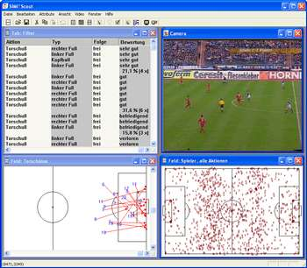  An example of a touch map.  This list could be used to promote discussion. Students then can analyse how attack and defense differ in terms of possession / tactics and so-on. Games can be tailored to blind criteria ie it is not only baskets that are awarded points, maybe rebounds are worth more ?  Sociograms will analyse patterns of play. This is very useful in deciding tactics and how to stop opponents. Students should be in numbered bibs. The players who are off each observe a player on court and draw lines to each number in which they pass to. This will highlight if they have a ‘go to man’.  Students need to appreciate how to outwit their opponent based on this information. | All lessons start with basketball related warm-up and re-cap work of previous lesson.  Make learning as active as possible  Give opportunities to plan tactics  Research rules on internet  Video to analyse performance  Tasks set to cater for levels of ability:  Distance from target  Size of practice area
5 & 6 | To introduce students to the different tournament formats.  - Round Robin  - League Tables  - Cup / plate / bowl  Students spend 2 lessons looking to organize, play and officiate a series of tournaments. They may wish to recap on the information explored similar to the sport education model. The criteria should be facilitated by the teacher but the criteria should largely be decoded upon by the students. All students in this process are expected to develop their K&U of tournaments formats, but also to improve their ability to officiate under pressure.  It is important that students develop their understanding of the different formats and experience playing in them.  Official signals | Issues to consider for example;  - Rules of competition / officals  - Duration of games  - Format / formats  - Fairplay / rankings  - Balanced competition  - Health & safety  - Scoring system  Round Robin format  Round 1. (1 plays 14, 2 plays 13, ... )  1 2 3 4 5 6 7  14 13 12 11 10 9 8  Round 2. (1 plays 13, 14 plays 12, ... )  1 14 2 3 4 5 6  13 12 11 10 9 8 7  Cup / Plate / Bowl  The cup is for the winner of the tournament. The plate is for the second-place team, the bowl for the third, and the shield for the fourth.  After pool play is finished, the top two teams in each pool advance to play for the the cup. The four losers of the first round drop into the bracket for plate competition.  Meanwhile, the third- and fourth-place teams in each pool play for the bowl. The four losers of the first round then go on to play for the shield.

