TENNIS Key Stage 3 Scheme of Work

Aims: Students are expected to develop a level of competence and confidence in their own ability to experience success through Tennis. By mastering the techniques and developing an understanding of the strategic intentions of net games, students should make rapid and sustained progress in relation to their entry level. An appreciation of the health and fitness demands of badminton will also give students a greater appreciation of what elements contribute to success.
PRIOR LEARNING  It is helpful if the pupils have:  - Developed a range of ground and overhead strokes.  - Understood key aspects of tactical play and technique  - Ability to select the appropriate strokes in game situations.  - Understood impact of exercise on health and fitness | LANGUAGE FOR LEARNING/ICT/CITIZENSHIP  Through the activities in this unit pupils will be able to understand, use and spell correctly word relating to tennis. Analyse, monitor, evaluate individual and team play. Use of ICT to analyse techniques and performance. Working with others. Watch video/compare professional game. Communication Speaking and Listening. Cooperation & working together. Develop word bank to support literacy across the curriculum. | RESOURCES  - Rackets & different compression balls  - Courts  - Access to information through ICT, ipads, flip cameras and you tube footage
Key Concepts and Processes:
Outwitting an opponent:  Pupils will identify different areas of the court and be able to move between these areas using a variety of techniques. Pupils will understand how to outwit opponents using strategies and tactics during game play. Pupils will learn and perform more basic tennis skills with accuracy and control. Continual development and adaptation of the necessary skills will contribute to producing an improved performance. | Developing Physical and Mental Capacity  Physical warm ups aid as a useful fitness tool in developing a pupils physical capacity. Use tennis skills to develop observation skills on peer performances, skills and techniques as well as observing the use of tactics. Ask questions about the effectiveness of these tactics. Students will also be given the opportunity to reflect on their own progress and evidence progress in their booklet. | Developing Skills/Performance  Pupils will develop the skills necessary to outwit opponents. Pupils will replicate shots with control and accuracy. Serves, ground strokes, volleys (forehand & backhand), drop shots & smashes will be developed through game play and conditional situations. Demonstrating high quality performances and accurate replication will be assessed.

Making and Applying Decisions  Pupils should be able to recognise the importance of responding to changing situations within the game in attack and defence. Pupils will be constantly faced with strategic and tactical decisions based on movement of the ball into space and choice of skill execution. Opportunities to score/coach pupils will develop communication and decision making skills. Students will be expected to develop a strategic approach to tennis and demonstrate their thinking through conversations and also their shot selection. | Evaluating and Improving  Appropriate questioning on teaching points of the skills and processes developed. Observation and peer assessment. Provide opportunities for pupils to assessment own performance and implement strategies for improvement. Logging progress in their booklets, using touch maps, notational analysis and video observations will all serve to develop their analytical skills. |  | Leadership and Officiating  Students will be given opportunities to develop both roles through leading warm ups, deciding on tactics, coaching their peers by providing clear and accurate feedback and designing practices to develop techniques.  Students will develop their understanding of the rules and develop their knowledge through being given the opportunity to officiate in singles and doubles games. Understanding both basic and more advanced rules to include setting, lets and errors across both formats.
Cross Curricular Links: Literacy (key words), Maths (scoring), Citizenship (sportsmanship), Science (bodily functions and healthy lifestyle consequences) |  | Assessment: Q & A, Formative and summative assessment. Video analysis, notational analysis, touch maps

Student Outcomes  Level 5 students will: make observations about the quality of decision making in modified versions of the full game, with support; show some consistency and accuracy in using a limited range of strokes/shots; contribute to discussion about tactics when guided; work effectively with a partner, and umpire using the key rules in a game; take regular exercise, sometimes involving net/wall games; form simple game plans based on observation and on the strengths and weaknesses of the opposition and their own team; identify strengths and weaknesses in individual performance  Level 6 students will: experiment with a range of tactics, searching for strengths and weaknesses in the opposition, and form a game plan; select and apply forehand with consistency and accuracy, possibly backhand and overhead strokes/shots in game situations in order to achieve particular outcomes and make adjustments where required; understand why regular exercise has a positive effect on their own health, fitness and social wellbeing and know where and how to become involved in regular physical exercise; use information gained from feedback to improve performance in game contexts and in personal technique; contribute effectively to team decisions, fulfilling various roles effectively, including umpiring and basic coaching | Level 7 + students will : demonstrate consistent decision making and appropriate choice of advanced techniques for desired outcomes in all aspects of the game; use a wide range of skills and techniques with precision, power and fluency; use a range of developed tactics to implement a game plan effectively; identify and prioritise aspects for improvement; use practices and exercises to improve performance; coach another player and select the focus for development of technique; organise and umpire games on both singles and doubles. Demonstrates competence in all roles as a performer, official and leader in both singles and doubles.
Learning Experiences across the key stage

Year 7: Objectives:

- Introduce students to the court markings and equipment used in tennis. Ball familiarity tasks to demonstrate control and accuracy. Introduction to the grip and stance. Court restriction games created to promote accuracy and depth in the forehand ground strokes. Ladders format to differentiate the ability in the group.
- Introduce students to the importance of effective footwork and understand how it links to shot selection. Split step, shuffle and base position. Analayse their own and others footwork to recognizing what good looks like and identify areas for development. Encourage students to play off their front foot, and return to ready position. Back hand and fore hand shots in isolation. ½ court games, with only groundstrokes allowed.
- To accurately replicate the basic technique for a forehand ground stroke P/E/R and understand the importance of movement and ball placement in order to win points. To begin to outwit opponents with the use of a forehand stroke. Where, when and how to execute the shot to outwit your opponent. Analyse your own and other students strengths and areas for improvement, ½ court games. Focus on DS & E&I.
- To introduce the students to the technique and rules associated with the serve, P/E/R. Encourage students to appreciate that the serve is a shot that can exploit opponent’s weaknesses when used effectively. Students should be able to discuss how, when and why different types of serve should be employed. Serving straight and diagonal. ½ court games both straight and diagonal for more able, round robin per court.
- Develop decision making through competitive ½ court games. Take part in a ladders tournament applying the rules of competition accurately and consistently. Reflect on progress across the unit and evidence it in your booklet.

Year 8 Objectives:

- Recap and develop student’s awareness of footwork, split steps, shuffle and playing off front or back foot. Reinforce both the ready position and base position and relate it to the desired movement pattern within the P/E/R of all shots. To be able to demonstrate & use forehand, and backhand for more able, in a rally. Develop the ability to outwit opponents with a combination of shots. ½ court round robin in groups of 3, 1 analyst.
- Develop an understanding of angled shots on both fore/backhand in straight and diagonal ½ court games. Appreciate the importance of positioning before and after shots. Reflect on own and peer performance and provide feedback. Emphasis on depth to the shot.
- To develop consistency and accuracy across ground strokes looking to impart spin and slice where appropriate. To evaluate their own performance and also that of their peers to suggest areas for improvement. ½ court round robin, 1 analyst. Look at E&I area of the wheel.
- To develop an understanding of the different techniques required to volley effectively in tennis (stop volley and half volley). To demonstrate some consistency and accuracy in the techniques on both the forehand and backhand. How, when and why a volley would be appropriate. To evaluate their performance identifying areas. Focus on DS & EI. 3 to a ½ court.
- To use notational or video analysis in competitive singles matches to provide feedback to peers on tactical play highlighting strengths and weaknesses. Students are to act in the role of a coach and design practices for an agreed weakness. Focus on E&I and DM.
- Competition in the form of a ladder tournament. Modified rules where appropriate dependent upon ability. Focus on leadership and officiating. 6 to a court, round robin format.
Year 9 Objectives:
- Recap ground strokes on both FH & BH with the focus on depth, accuracy and consistency. Cooperative / competitive rallies to promote competence. Focus on DS & E&I.
- Recap types of serve, slice and punch to set up 2nd shot. Uses serve a tactic to exploit potential backhand weakness. Think about positional play from the serve? Narrow the angle or attack the net to set up a volley return. Evaluate the effectiveness. Focus on DM.
- Introduction to lob. How, when and why it would be used a technique or tactic in a game. How can an effective lob counter a deep serve? Focus on DS area of the wheel.
- ½ singles Tournament play. Modified rules. In 3’s, students umpire with correct scoring compete in a 3man round robin before progressing to a ladder format. Winner moves up, loser down. Evaluate own and other students performances, demonstrating effective analytical skills, design a game plan to counter their strengths. Focus on leadership and officiating. This could be over 2 lessons to ensure all students officiate accurately.
- An introduction to doubles play and how skills previously learnt can be applied to doubles. To learn court lines and the relevant scoring in doubles play. To understand the different positional play required in both attack & defense. To devise tactics to outwit their opponent for successful performance. Focus on DM, communication.
- To officiate and compete in a variety of competitive formats in both doubles and singles. Evaluating opponent’s strengths and weaknesses and exploiting these through effective tactics. Focus on E&I and officiating.

Extension & Enrichment

Out of lessons, at home and in the community, pupils could be encouraged to:
• practice skills at breaks and lunchtimes and at home
• take part in school sport, either competitively or socially
• join clubs in the community and/or use local facilities
• watch live and recorded matches to appreciate high-quality performance
• search the internet to find information about sports and opportunities to take part in sports, eg www.english.sports.gov.uk

Language for learning
Through the activities in this unit pupils will be able to understand, use and spell correctly words relating to:
• tactics and techniques,, base position, ready position, angles, forehand, backhand, overhead, , drop shot, volley, staying in the rally, finishing the rally, tactics, game plan, success criteria, officiating/umpiring, adjustments/variations, anticipation, fitness

Speaking and listening – through the activities pupils could:
• solve a problem, consider alternatives, structure plans and organise group activity

1 | Fundamental skills, footwork and handling.  - To develop an understanding of tennis related footwork including the split step, base position and shuffle  - To be able to demonstrate & use the correct grip  - To understand the basic scoring and rules of game play.  - To begin to think about outwitting opponents with the movement of the ball. | Discuss prior knowledge of tennis. Scoring system for a game.  Rules:  Lose the point if: ball bounces twice before you hit it, hit the ball out, hit the ball into net, hit the ball twice. (Winning a point task card to support)  Points system (game) : 15, 30, 40 (deuce if 40 all/next point advantage to winner then game or back to deuce), game.  The split step is the first reaction to every shot you must return. The split step is a maneuver performed when you jump up an inch or two onto your toes as your opponent is about to hit his/her shot. Your feet should be about shoulder width apart, and your knees should be slightly bent when you land. This body position keeps you off of your heels and ready to move quickly to any position of the court. The split step should be used when you are returning serves, ground strokes, volleys and when you are approaching the net for a volley.  TASK: In pairs over the net throw a tennis ball from either hip (a forehand or backhand technique) to either side of partner. Partner to split step when the partner is about to release so they can react left and right. (5 mins)  PROGRESSION: try and catch each other out by disguising the throw to encourage fast reactions after split step. (2 mins)  Introduce ready position and shuffle.  While hitting ground strokes, the tennis footwork plays a key role and is the most important thing to focus on. For each ground stroke to be made, you have to get back to the middle of the baseline of your court after you hit each shot.  The key of the shuffle is avoid turning your whole body 90 degrees when running back to baseline of your court, here the shuffle simply comes in action. While heading back to must have to face your opponent, shuffle your feet to head back towards to the middle of the baseline.  TASK: Return to game and focus on shuffle and returning to base position after each shot. (5 mins)  Recap progress of footwork.  Introduce rackets. ‘Shake hand’ grip. Half court. Discuss different  ground strokes – forehand/backhand. Focus is on effective  footwork NOT the success of the return.  TASK: RADAR - Feeder faces partner with ball in hand in the  service box. Partner faces partner on the service line. Feeder  says backhand or forehand and throws the ball to that side of  partner for them to return the ball and return to base position.  If in 3’s the other pupil can assess the effectiveness of footwork.  Split step, shuffle and return to base.  Pupils to have 5 attempts then switch roles. (15 mins)  Progressions: - Don’t call out which way ball is going and just react to throw  - Faster overarm throw  - Stand in between the service line and baseline to return  Application:  - In 3’s. Pupils to rally and focus on footwork. TWO bounces allowed. 3rd player provides feedback. Rotate.  - Play half- court game with 3rd pupil as official. Rotate after a game. Underarm serve from service line. | All lessons start with Tennis related warm-up and re-cap work of previous lesson.  Make learning as active as possible  Give opportunities to plan tactics  Research rules on internet  Tasks set to cater for levels of ability  Number of touches  Distance from target  Size of practice area  Size of target
2 | Forehand Groundstroke  - To accurately replicate the basic technique for a forehand.  - To understand the importance of movement and ball placement in order to win points.  - To begin to outwit opponents with the use of a forehand stroke.  - To confidently score a game. | Discuss footwork from last lesson. Introduce the names of the court lines.  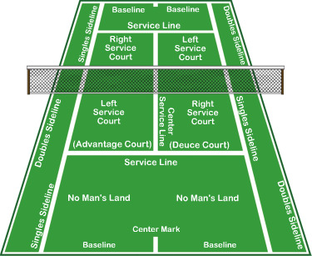  WARM UP: In groups of 6. ‘Pacman’ on half a court. Pupils to always face  the net. 1 is ‘on’. Move around the court lines and attempt to tig other  members of the group. Movement should be specific to tennis. Low centre  of gravity, knees bent. Shuffle sidewards with hands in front as if holding  racquet. Stretch (5 mins)  Introduce hand shake grip and demonstrate the forehand stroke.  Technique:  Preparation  -Hand shake grip  -Draw racket back  -Turn sideways  -Step towards ball  -Weight on back foot  Recovery  -Continue to swing, finish high  -Point racket towards target  Execution  -Transfer weight forward  -Non-hit foot forward  -Swing racket through  -Keep wrist firm  -Contact made in front of body  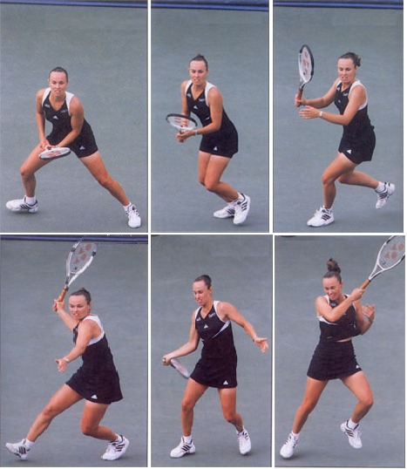  Pupils to get into groups of 3 with a task card.  TASK: Feeder to stand in service box and partner to stand on service line  over the net. 3rd member of group to stand at side of net and focus on  partners technique. Provide feedback after 5 strokes each. Don’t return  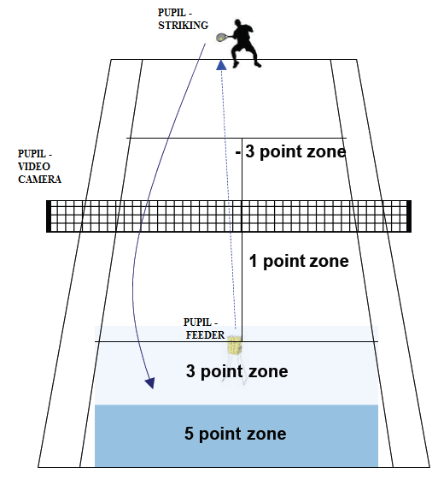  stroke (10 mins).  PROGRESSION: More able pupils - Make pupil move around the baseline  by feeding wide or into the body. Focus on footwork dependent on feed.  Discuss progress of technique. Link with previous lesson on footwork and  introduce placement of shot. Pupils to discuss the difference between a powerful  shot and a placed shot. Which is more accurate? Why?  TASK: Pupils now to face 5 feeds each and aim to hit their forehand stroke  into one of the target zones (illustrated right). -3 for wide or long also.  Keep score and compete with partner.  Video camera to be used to watch technique. Whilst the balls are being  collected the player who hit them watches their performance back to  look at technique.  TASK: Pupils to play a forehand rally in half courts – if both players play  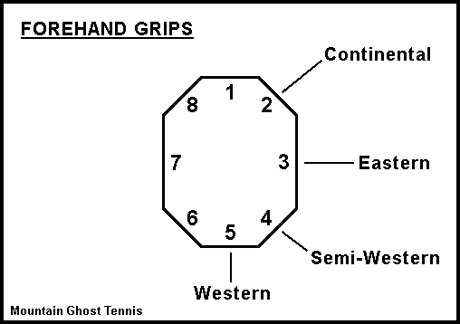  off the same hand then they must be informed to play cross court instead of  down the line. Opposites can go down the line. This will ensure that pupils  remain on the forehand. Pupils must return to the base position before the  next shot.  Pupils start position can vary dependant on ability. Preferably in between  service line and base line for start point even if the ball has to bounce twice  before reaching partner. Player 3 can provide verbal feedback to the pair  whilst playing.  APPLICATION: Pupils to play a half court match. 3rd pupil to umpire  with rule card. 1 game to be played then rotate players. Backhand shots  can be played but focus is on technique and placement of forehand shots.
3 | Backhand Groundstrokes  - To accurately replicate the basic technique for the backhand stroke.  - To understand the importance of movement and preparation for an effective backhand shot  - To understand how to adjust shot selection based on opponents positioning. | Recap forehand technique. Introduce games and sets.  WARM UP: Around the world forehand rally. Less able pupils can strike from closer than the service line. Pupils can go around the other side after strike or to back of own line.  Introduce backhand grip and technique. Demonstration.  Pupils to get into groups of 3 with a task card.  TASK: Feeder to stand in service box and partner to stand on service line over the net. 3rd member of group to stand at side of net and focus on partners technique. Provide feedback after 5 strokes each. Don’t return stroke (10 mins).  PROGRESSION: More able pupils - Make pupil move around the baseline by feeding wide or into the body. Focus on footwork dependent on feed.  Discuss progress of technique. Compare with forehand stroke and decide which you are more comfortable at playing. Pupils to discuss the difference between a powerful  shot and a placed shot. Which is more accurate? Why?  TASK: Pupils now to face 5 feeds each and aim to hit their forehand stroke into one of the target zones (illustrated above, right). -3 for wide or long also. Keep score and compete with partner. Video camera to be used to watch technique. Whilst the balls are being collected the player who hit them watches their performance back to look at technique.  TASK: Pupils to play a backhand rally in half courts – if both players play off the same hand then they must be informed to play cross court instead of down the line. Opposites can go down the line. This will ensure that pupils remain on the backhand. Pupils must return to the base position before the next shot. Players can rotate in so no one is off.  Pupils start position can vary dependant on ability. Preferably in between service line and base line for start point even if the ball has to bounce twice before reaching partner. (10 mins)  TASK: Link to previous lesson with forehand stroke. Pupils to play half court games. They must hit alternate backhand  and forehand shots in order to win the point. Play a mini set of 3 games. A game to be recorded for each player on the video camera.  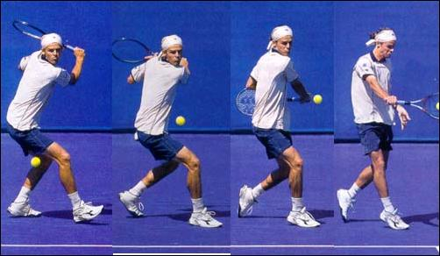  Preparation  -Backhand grip  -Draw racket back  -Turn sideways on with with hitting arm across body  -Step towards the ball  -Weight on back foot  Execution  -Transfer weight forward  -knuckles facing forward  -Shoulder rotates into ball  -Hitting foot forward  -Contact made in front of body  Recovery  -Continue to swing (C shape), finish high  -Point racket towards target
4 | Forehand/backhand development  - Develop an understanding of angled shots on both fore/backhand  - Appreciate the importance of positioning before and after shots.  - Reflect on own and peer performance and provide feedback. | Pupils to lead own warm up in half a tennis court. 3 balls can be used.  Pupils to discuss the selection available to them once they are able to use the correct technique for fore/backhand strokes.  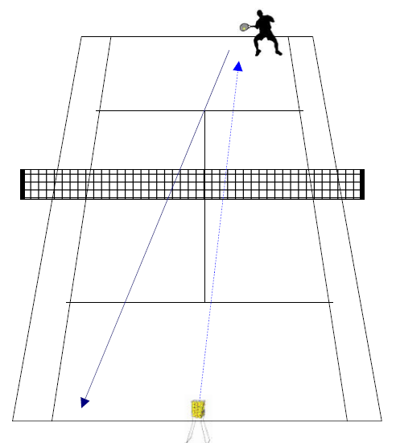  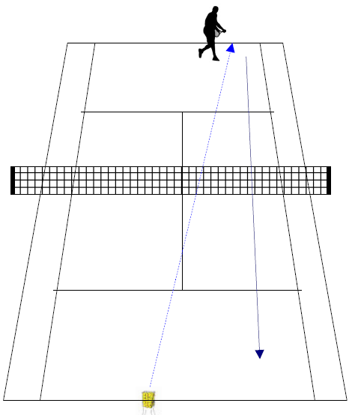  http://www.teachpe.com/tennis/offensive/cross_court.php  http://www.teachpe.com/tennis/offensive/down_line.php  http://www.teachpe.com/tennis/offensive/down_line_backhand.php  http://www.teachpe.com/tennis/offensive/cross_court_backhand.php  TASK: Cross court and down the line strokes. Pupils to practise stroking the ball  cross court and down the line. 1 to strike. 1 to feed. 1 to video record performance.  Pupils to have 8 shots each (4 balls). This task can be differentiated by the feeder.  To challenge pupil shout what shot to play after the feed. Faster, flatter feeds can  also challenge pupil.  Pupils to now link in previous lessons to succeed in a number of challenges.  CHALLENGE TASK:  STANDARD INTERMEDIATE ADVANCED  FOREHAND RALLY ALTERNATE STROKE RALLY ALTERNATE RALLY INC SLICE  BACKHAND RALLY CROSS COURT/DOWN THE LINE RALLY ALTERNATE CROSS COURT/DOWN LINE RALLY  Each rally total to be decided on by the group beforehand to challenge them. All to attempt  3 challenges from at least 2 difficulties.  Discuss with group about angles of shot and positioning. Pupils need to understand how to  Select the correct shot and follow it with an optimal position to attack opponents return.  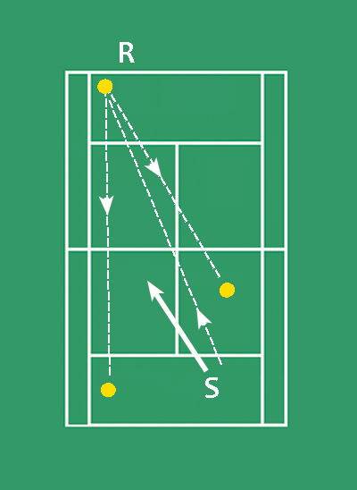  S shows the correct positioning after playing a shot into the corner for R to return.  Positioning should be in between the two widest possible returns from where the opponent  is.  APPLICATION: Pupils to play a half court match with a focus on positioning after  each shot. 3 strokes must be played over the net before the point is live. 3 game match.  Underarm serve from service line.  Pupils to then discuss the different approach for cross court singles with regards to  positioning and shot selection.  APPLICATION: Cross court singles. Rules - Same as above.
5 | Service  - To accurately replicate the technique for a basic serve  - To understand the rules associated with serving and a tiebreaker.  - \To demonstrate understanding in a competitive scenario. | WARM UP: Pupils lead own pulse raiser and stretches.  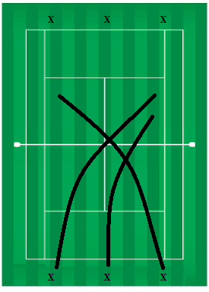  Pupils to get into groups of 6 on a court (9 if need be). 1 ball  between two. (4 balls if 9 pupils). Pupils to stand behind the base line on each  side. All balls at one end. Pupils are to throw the ball over the net diagonally  into the service box (replicating the serve). Pupils on the other side are to catch  the ball before it bounces twice. Competition. Face pace as still part of warm up.  Guided discovery approach to realise the importance of striking ball at highest  point, fast serve success %, looped serve success %, which outwits opponents  more. Pupils also to get used to serving opposite and experiment with start  position to create angles.  RULES: Just like serving the pupils can’t step on or past the line before or  during serve. Serve must go diagonally and land in the service box. If out or  hit net then it is a fault and a second serve will be taken. If it hits the net and  bounces in it is a let and that serve will be retaken (whether first or second).  Serve technique.  Preparation  -Side side on with non strike foot just behind line  -Ball and racket together just in front of body  -Continental Grip  -Weight on front foot  Recovery  -Continue to swing  -Momentum should take body into court  Execution  -Toss ball up in air and lower racket down and back  -Transfer weight onto back foot  -Strike ball at highest point  -Weight back onto front foot with follow through  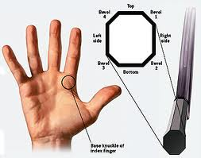  http://www.teachpe.com/tennis/serves_and_returns/flat_serve.php  TASK: In 3’s. 1 racket. 1 video camera and other pupil gathers balls. 5 balls  each. Cross court ½ court to practise serve. Pupils to practise with power and  with a placed shot. What are the differences in the outcome? Why?  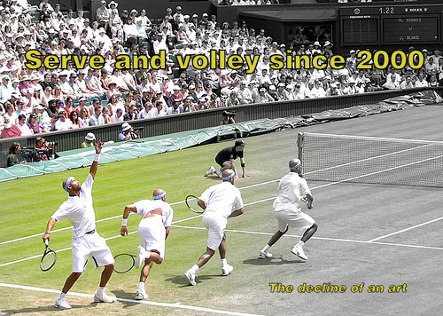  Less able pupils can aim past service box at first to practise hitting over the net  More able pupils can aim to serve to forehand, backhand or into body of  opponent.  Pupils to discuss how to use the service to outwit opponent. Identify S&W of  Opponent, serve to weakness.  TASK: Pupils to take turn serving 3 serves, other player return ball and server  to follow in to close down the angle. Play 3 serves each and rotate.  Discuss rules of a tiebreak. 1 serve followed by 2 serves each until 7 is reached. If 6-6  then tie break continues until the player has won by 2 clear points. When is a tie break  played?  APPLICATION: Pupils to play a cross court tiebreak with other player  umpiring.
6 | Conditioned games  - To demonstrate all prior learning into matchplay including footwork, fore/backhand, serve.  - To demonstrate understanding of the rules in performance and umpiring. | Warm Up – Pupils to lead own pulse raiser and stretches in 6’s per court.  Pupils to be reminded of progress to date.  Conditioned games to be completed in the same manner. 1v2 with 3 umpiring. Rotate.  Condition 1 – Only the serve can land in the service box. Every other shot must be longer than the service box. ½ court.  Condition 2 – All shots must land within the service box. ½ court games.  Condition 3 – Pupils must play alternate shots of forehand/backhand strokes.  Condition 4 – Cross court games.  Condition 5 – Cross court games – alternate shots of forehand/backhand strokes.

1 | Basic ground strokes  To be able to demonstrate & use forehand and backhand shots in a rally.  To develop the ability to outwit opponents with a combination of shots.  To develop strategic and tactical play during a rally. | Warm Up: Pupils to lead won pulse raiser and stretches.  Discuss technique for forehand and backhand strokes.  Pupils to get into 3’s and complete the following tasks. Forehand  Preparation  -Hand shake grip  -Draw racket back  -Turn sideways  -Step towards ball  -Weight on back foot  Recovery  -Continue to swing, finish high  -Point racket towards target  Execution  -Transfer weight forward  -Non-hit foot forward  -Swing racket through  -Keep wrist firm  -Contact made in front of body  1 to strike  2 to feed  3 to gather balls  TASK: Pupils to take turns in practicing the forehand and backhand  stroke. Pupils to face 5 balls for forehand and backhand and aim to  strike them deeper as this is harder to return. Points will be awarded  like below.  PROGRESSION: Pupils will be told what shot to play once the ball has Backhand  been thrown so the focus is on preparing the forehand or backhand shot.  Recovery  -Continue to swing (C shape), finish high  -Point racket towards target  Execution  -Transfer weight forward  -knuckles facing forward  -Shoulder rotates into ball  -Hitting foot forward  -Contact made in front of body  Preparation  -Backhand grip  -Draw racket back  -Turn sideways on with with hitting arm across body  -Step towards the ball  -Weight on back foot  Pupils to discuss the cross court and down the line shot.  Remember when hitting forehand cross court to have a wider stance to  allow the rotation to occur at the hips. Same rotation occurs with backhand  cross court.  When hitting down the line the weight should be on the front foot  (fore – non hit foot, back – hit foot).  Pupils to now try and play a rally including cross court f/b and down  the line f/b. Try a 7-10 shot rally with these strokes included.  Pupils need to know that hitting deeper shots increases difficulty for return. Being able to  play a variety of forehand and backhand strokes provides a player with more opportunity to  outwit the opponent.  APPLICATION:  Pupils to play half court games with a cone in the middle of the base line. After each shot the  pupil must return to the base position. Game is live after 3 shots over the net. Underarm serve  from the service line. | All lessons start with Tennis related warm-up and re-cap work of previous lesson.  Make learning as active as possible  Give opportunities to plan tactics  Research rules on internet  Tasks set to cater for levels of ability  Number of touches  Distance from target  Size of practice area  Size of target
2 | Volley and lob  - To accurately replicate the approach, drop volley and the lob with control and accuracy  - To identify S&W of own and partner work  - To be able to link skills into game situation with control, fluency and consistency | WARM UP- pupils to recap last lesson with half court rally with alternate strokes. Aim for ten. Rotate a 3rd player in at one end.  Introduce volley. Why and how to volley. A volley is performed from within the base line and net so the footwork and movement to get into position is essential to perform a successful volley. There are a number of volleys to play. In this scheme the forehand approach volley and forehand drop volley will be introduced.  The teaching points for the approach volley  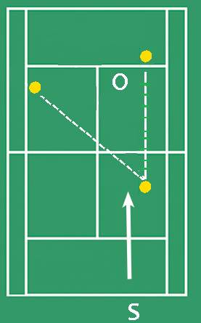  How: Using the continental grip players are required to stop quickly as they make  their way into the net to gain control of the approach volley. If a player is still running  when hitting the ball it makes the volley almost impossible to control, and the ball could  end up anywhere.  Having said this players should still try and step into the shot. The ball should be hit well  in front of the body, the hips and knees should be low, and the head kept still.  Not much of a swing or follow through should be needed, just the opponents power from  the incoming ball, to send the ball straight back over the net. Again balance and timing are  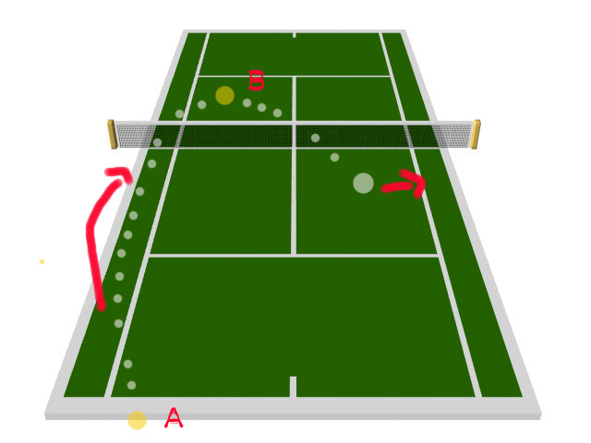  crucial in hitting a successful approach volley. After hitting this shot players should move further into the net  Points to remember: Send the ball down the line if the player is positioned wide, or if the  player is standing in the center of the court, they should play the ball back down the center  to reduce passing angles.  Teaching points for drop volley  How: When attempting a drop volley it is important that the player lets the wrist flex on contact  with the ball, this ensures some of the power is soaked up by the strings, and hopefully drop the  ball just over the net. There is no follow through involved in this volley as any forward movement  of the racket may cause the ball to drop in the mid-back court area, and control of the point would  be lost.  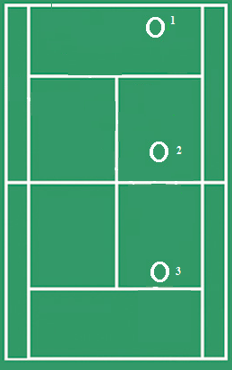  Points to remember: Loosen the grip just before contact is made with the ball. Try to disguise the  shot as much as possible so it is not read by the opponent, giving them enough time to choose a  passing winner.  Images show the different end positions for the two different types of volley.  TASK: In 3’s . 1 to strike, 1 to feed and 1 to gather balls and provide feedback with the use of  video camera. 5 attempts at each type of volley on forehand only. More able pupils can attempt  backhand volleys also.  PROGRESSION: Once everyone has had attempted the feed task then progress to baseline to volley  rally. One player on base line and one player on service line. Step into volley and volley back to player  on base line. Have cones for base position to recover to after each shot.  Introduce lob shot. Weight on back foot. Backswing is constant and instead over an oval shape sidewards the movement is a vertical oval shape  http://www.teachpe.com/tennis/lobs_and_overheads/topspin_forehand_lob.php  In 3’s pupils to perform the following drill to work on volley, lob and forehand groundstroke. O1 to stand on baseline and must hit a forehand ground stroke. O2 must hit a volley and O3 lust try and lob O2. Rally so not a winning volley or groundstroke.  APPLICATION: Loaded scoring ½ court games. 1 point for a winner from a groundstroke, 2 points from a lob and 3 from a volley. Think about moving opponent around the court in order to achieve higher scores.
3 | Independent learning  - To identify own and partners S&W  - To think creatively to devise own developmental practice to improve W  - To devise own small tournament with conditioned rules to allow for fair contest | Warm up – Pupils to lead own pulse raiser and stretches.  Pupils to discuss the topic covered so far – Split step, fore/backhand strokes, approach/drop volley. In the groups of 3 from last lesson pupils to create a developmental practise that aims to improve a weakness. More able groups can look to develop more than one area in the practise. Suggestions could include:  Inside out cross court  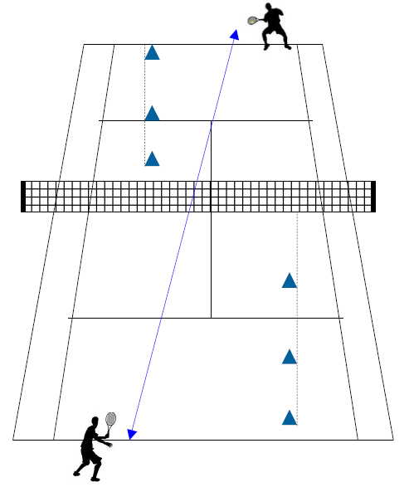  Cross court  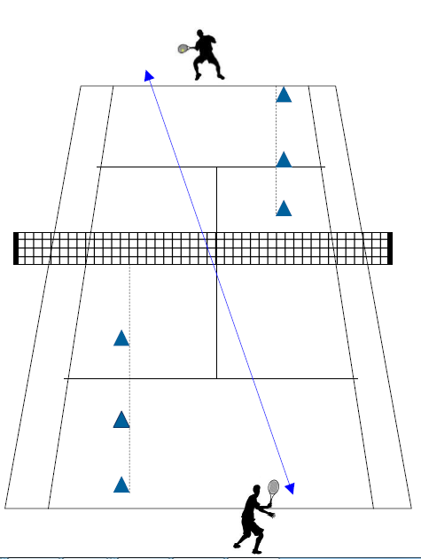  Forehand / backhand strokes  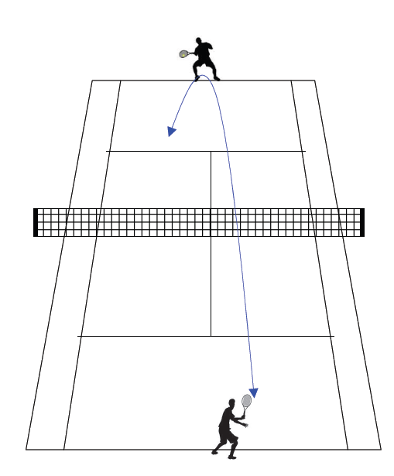  Depth  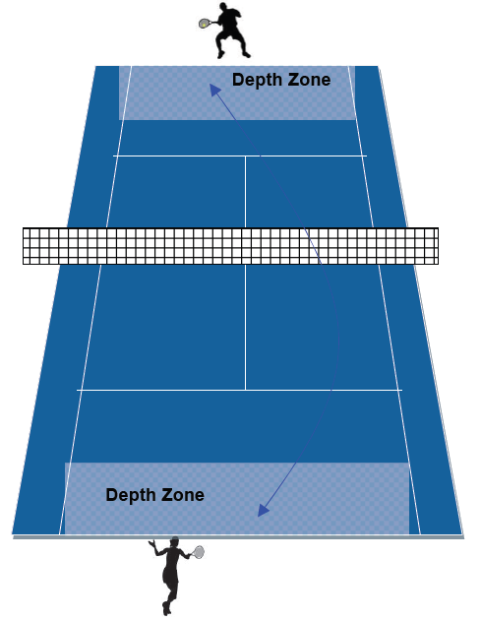  In to attack and recover  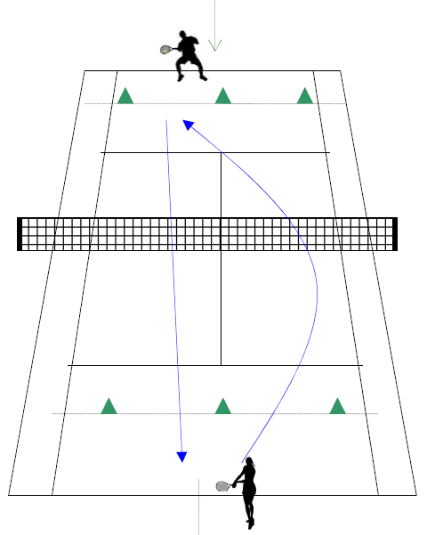  Down the line  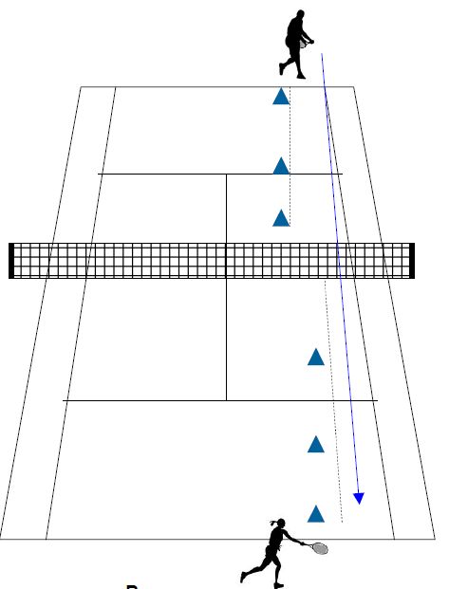  Lob and drop shot  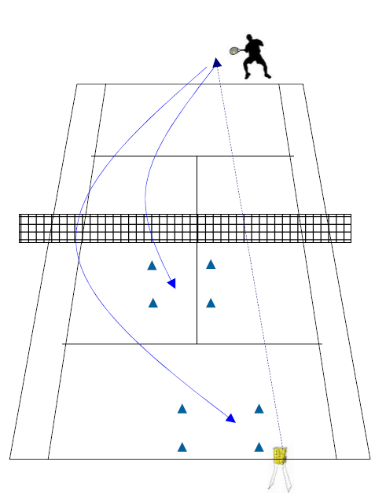  Approach/Drop Volley  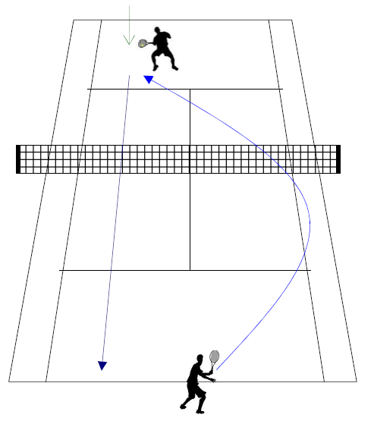  Alternate stroke Fore/Back  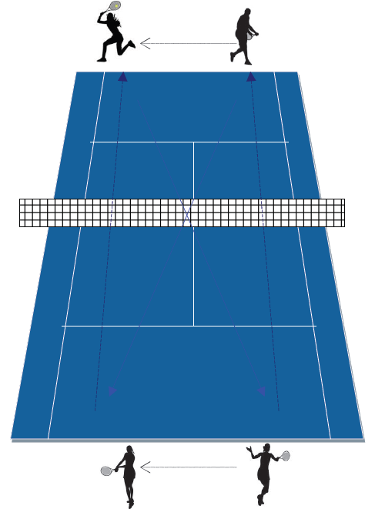  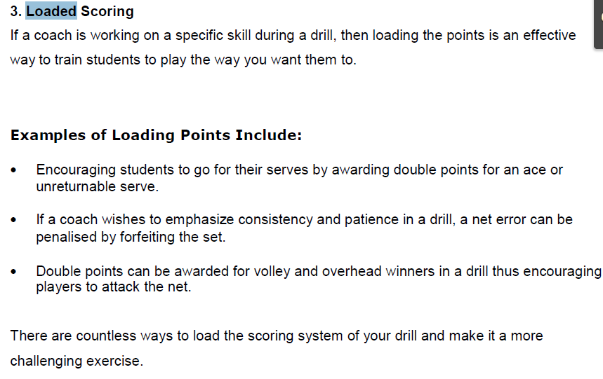  APPLICATION: Working in same groups pupils are to devise their own ½ court round  robin tournament. The points are to be loaded and tie breaks are to be played with  underarm serve to allow for more than point to won at once.  Pupils can also differentiate games to make the matches more even. More able pupil  Restricted to winning points on their weak shot or in the tram lines. Less able pupils can  win points for attempting certain shots.  At the end of the lesson, students should reflect on their progress and have a clear  understanding of what NC level they are working at and how they can improve. Conversation  with the teacher should confirm their understanding of their own strengths and areas for  improvement.
4 | Serve, return, 3rd shot.  - To develop an understanding for different types of service.  - To develop thinking skills in preparation for shots – angles.  - To identify strengths and weaknesses of self and opponent | Warm up – Pupils to lead own pulse raiser and stretches in half courts. Shoulders warm up thoroughly before serving commences.  Recap basic serve and introduce slice serve. http://www.teachpe.com/tennis/serves_and_returns/slice_serve.php  TASK: In 3’s pupils to practise the serve in 1/2 cross court. Pupils to focus on technique for the 1st 7 serves each. Try both types of serve.  It is the one shot in tennis that you are in total control of, so do not waste the opportunity by rushing. Spend time getting your set-up right and getting your mind focused on what you are trying to do and where you are trying to hit the serve.  Preparation  -Side side on with non strike foot just behind line  -Ball and racket together just in front of body  -Continental Grip  -Weight on front foot  Execution  -Toss ball up in air and lower racket down and back  -Transfer weight onto back foot  -Strike ball at highest point  -Weight back onto front foot with follow through  Recovery  -Continue to swing  -Momentum should take body into court  The slice serve is slightly different. The ball is tossed slightly more to one side  and the contact is made to the side of the ball. This will cause the spin to spin to  one side over the net.  TASK: Pupils to now attempt 5 serves at 100%, 5 serves at 75% and 5  serves at 50% and record where the balls landed. Which was more  successful – power or accuracy? Why?  Pupils to discuss how to tactically use the serve to get an advantage over  opponent. Where can you serve? Forehand, backhand or into the body.  Advantages of each?  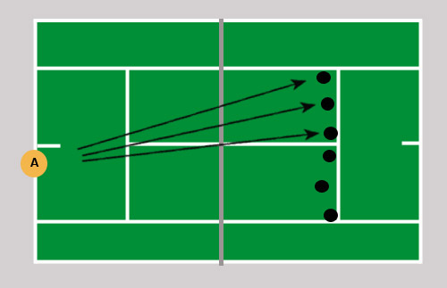  TASK: Pupils to place 3 cones in te service box dividing it into 3 channels –  Forehand, backhand and into the body. Have 6 attempts to aim the serve into  the service box.  Discuss the return of serve. Highlight the importance to split step as the opponent  serves. This will provide a spring to move towards the ball. The next task will look  at the 3rd shot. Therefore pupils discuss possible tactics to employ by the server to  set up a 3rd shot. Possible tactics :  - serve wide and expect return down the line and play cross court  - serve into body and follow in to volley the return  - serve to weak area of opponent and close the angles for return  TASK: 1n 3’s. Pupils to play cross court singles. Serve properly. If two faults  then underarm serve. The point starts with the 3rd shot so an ace or winning  return will not be successful. Play tie break. Rotate.  The pupil who is not playing is to umpire match.  Pupils given reflection period in 3’s to discuss success of performance. They should highlight strengths and weaknesses of own and peer performance and think of strategies they can employ in order to progress.  APPLICATION: Pupils to play cross court tie breaks. Normal rules apply. Non playing pupil to umpire.
5&6 | Match play  - To demonstrate the ability to outwit an opponent in a match using the appropriate skills and shot selection.  Lesson 5 - Tactical development  Pupils are to divide into 3’s. 1 to umpire and 2 to play. ½ court. Pupils to be given tactics cards with the following:  - Percentage shots v winners  - Net play v base line  - Base line v baseline  Pupils as a group to come up with strategies that would be useful to employ with these tactical approaches.  Pupils to play ½ court matches attempting the different strategies/tactics. Discuss each throughout the lesson. Possible discussion points:  Percentage shots  Go for high net clearance (preferably with some topspin). This should ensure good depth, keeping your opponent back.  Avoid changing the direction of the ball when it is hit with pace or directed towards your weaker wing or if the ball is low.  Aim straight ahead with approach shots. This should ensure your opponent has minimal opportunities to use angles on the pass.  Expect to hit at least two volleys to win a point (one to set up, one to put away). This should ensure a better court position to finish the point.  Get the first serve in, aiming for placement rather than power. This should ensure you save energy (the cost of executing 2 serves per point adds up!). It should also avoid the threat of your opponent moving in on second serves.  When in trouble - lob! This should ensure you buy time to recover a reasonable court position and you frustrate your opponent by neutralising his or her attack.  Playing the percentages also involves taking into account your strengths and weaknesses, your opponent's strengths and weaknesses, the court surface and the playing conditions (e.g. the weather).  Exploit your opponent's weaknesses sensibly (if you overdo it, he or she will improve or find a way around it!) and try to play shots that will entice your opponent to hit to your strengths.  Winners  Forceful first serve. Hit low fast strokes into the spaces. When playing aggressively, the idea is to move the player around and constantly keep the off balance or on the run. Until you get the short ball.  Don't go for too much on the first-serve return. Your first objective should be to make your opponent play another shot. Shorten your backswing and direct the ball back along the line of the serve.  You've got to view your opponent's second serves as big opportunities. Consider going down the line. Consider generating more pace. Consider a chip-and-charge combination.  Being aggressive on the second serve return may make your opponent go for more pace or depth, risking more errors. It may also force your opponent to play safer with the first serve!  Baseline v net shot  Either stay on the baseline and attempt to play the space or come into the net after a shot to the corner to play a drop or drive volley from within the service box. Exploiting the baseline tactic can be through disguise or a drop shot. Exploiting the net play tactic can include lob shots, body shots and disguise.  - The pupils are to demonstrate their knowledge and understanding of the rules in tennis.  - To demonstrate a variety of tactics based on the movements of others.  - To use strengths and weaknesses of self and opponent as part of tactical development | Pupils lead own warm up. Both lesson 5 and 6 will be done through match play.
Lesson 6 – Strengths and Weaknesses

Pupils to play ½ court singles ladder tournament and a cross court singles ladder tournament.
Name: Timmy

Strengths Weaknesses
Forehand strokes 1 Backhand strokes
Drop volley 2 Lob shot

Opponent identified strength and weakness
- Drop volley W Forehand cross court
- Lob shot L Backhand cross court
- Forehand W Backhand
Pupils to identify their own strengths and weaknesses and record these on a task card.
Before each match (4 minutes long – tie break style) the pupils are to give their own card to
Opponent so they can study how to tactically prepare for match. Idea is to play against
Weaknesses and avoid strengths. More able players will be able to manipulate the match to suit.

After each match the opponent is to write a strength and weakness on their opponents card,
record whether THEY won and return the card. Get own card back and then play against
another player who studies the prior performance and perceived S&W to tactically prepare.

Discuss different approaches to games. Why? How?

Pupils to play cross court singles ladder tournament.
Pupils to use NC level descriptors to assess performance.. After playing a number of cross court games and thinking about prior learning place themselves again on timeline to see pupils to place themselves somewhere on the ‘timeline’. Set a target to improve.

1 | Ground strokes/ Outwitting opponents  Objectives;  - To develop consistency and accuracy in the execution of the fore hand ground stroke in tennis  - To understand how this can be developed to include top spin to outwit an opponent  - To evaluate their own performance and also that of their peers to suggest areas for improvement  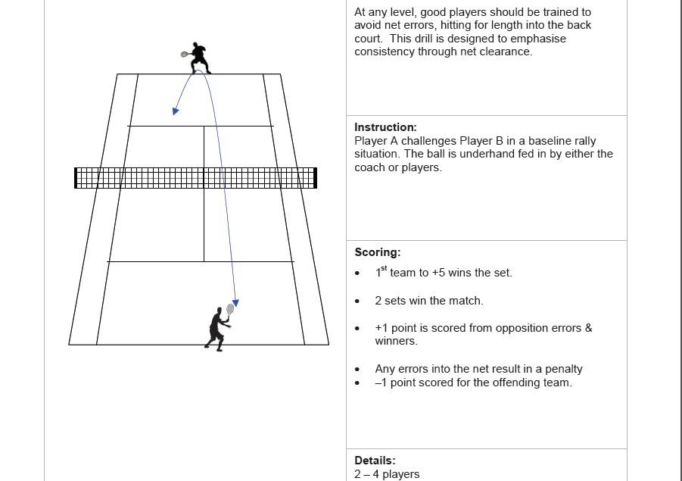  phase one - the backswing. Turn your shoulders so your racket points to the fence behind you. It's a good idea to do this as early as possible. With the racket already behind you, track the ball with your non-racket hand and adjust your feet so that you can be in a good position  - phase two - the contact. With your feet approximately shoulder width apart, bend your knees slightly, lowering your centre of gravity. Swing the racket forwards and slightly upwards. Ideally, the ball should be a comfortable distance away from your body and somewhere around hip height. Aim to make contact with the ball just in front of your hip with your wrist braced and the racket face vertical. Transfer your weight into the shot and straighten your legs  - phase three - the follow-through. Your racket continues forwards and slightly upwards through the line of the ball. Once you've learned to control the racket face, aim to produce a really full follow-through.  -phase four.  use small side-skips to recover to a good position on the court, ready for the next shot. Hold the racket out in front of you and establish your balance by performing | Warm up – Student led. Recap prior learning– ½ court rally  Recap & demo basic strokes + outwitting opposition. Highlight ball placement (deeper= harder to return) & outwitting opposition.  Task 1  Students should be encouraged to make a full swing and attempt to carry the ball beyond the service box. This is a cooperative rally in which the students focus on mastery of the technique. One player videos another students technique from the post and uses this for feedback both formative and summative. Rotate every 2 minutes. Recap on the footage to identify strengths and areas for improvement.  Task 2  Now Students should be encouraged to make a full swing and attempt to carry the ball beyond the service box and are awarded a point for each successful attempt. The game is played against the clock and students will move up or down dependent upon their score. Games are played in groups of 2 or 3 dependent upon numbers.  This will allow the group to differentiate itself on the technique being developed.  Task 3  Task mastery.  In 3’s one student acts as a feed and the other attempts to develop power and accuracy in their technique. The 3rd player returns any loose balls to the feeder. Rotate roles. The student returning the ball plays, a fixed number of balls at different % of their hitting capacity.  Measure the successful of hitting the balls with greater power; discuss the implications of a speed / accuracy trade off and how tactics can be employed to outwit the opposition who may be stronger than you.  Task 4  Students now play half court singles where games last for 5 minutes and students have 4 serves each with must be a ground stroke. Each time a serve in played, the ball must carry the net 3 times before the point comes alive.
2 | 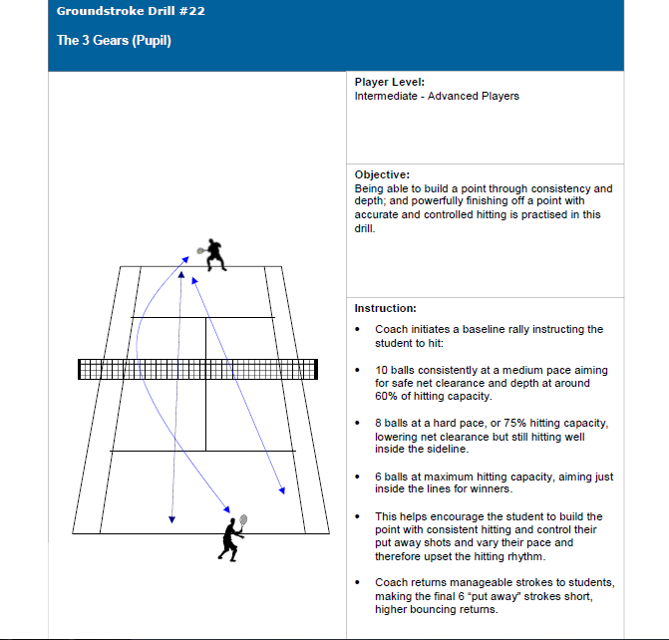  Lesson 2  Objectives  - To develop consistency and accuracy in both the forehand and backhand in tennis  - To link effective footwork to both shots.  - To evaluate their own performance and also that of their peers to suggest areas for improvement  http://www.teachpe.com/tennis/offensive/down_line_backhand.php  The aim of the backhand is to hit down the line shot can be used to break the pattern of cross court shots and catch an opponent off balance, and make the opponent run a considerable distance to reach a shot that is traveling a much shorter distance.  Cross court backhand  http://www.teachpe.com/tennis/offensive/cross_court_backhand.php  This is an excellent shot to return the serve with as it gets the server on the move straight away, and with the cross-court shot greater angles can be created, making it difficult for an opponent to return the ball with any power or placement | Task 5  Students can play diagonally, ½ ct games. This will narrow the angle for the cross court shot but allow for more depth on the shot the corners.  Students should be given the opportunity to practise their technique in isolation, under pressure situations and also in competition. Time must also be provided for students to demonstrate their ability in games and vary their technique to include top spin, drop shots on passing shots.  Students should always start the next lesson on the half court they finished on the previous lesson. This will allow the groups to differentiate themselves on ability.  Lesson 2  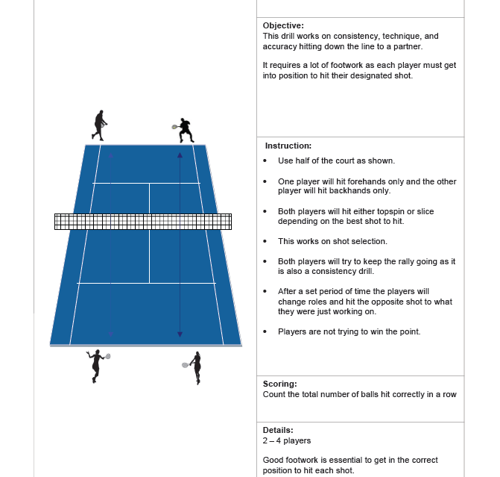  Students initially have a hand feed that allows the returner to focus on their footwork and getting into position early. The returner is trying to pass the feeder to the 3rd man standing beyond the tramlines. Points are awarded for accuracy. The roles can then be rotated every 6 feeds.
3 | 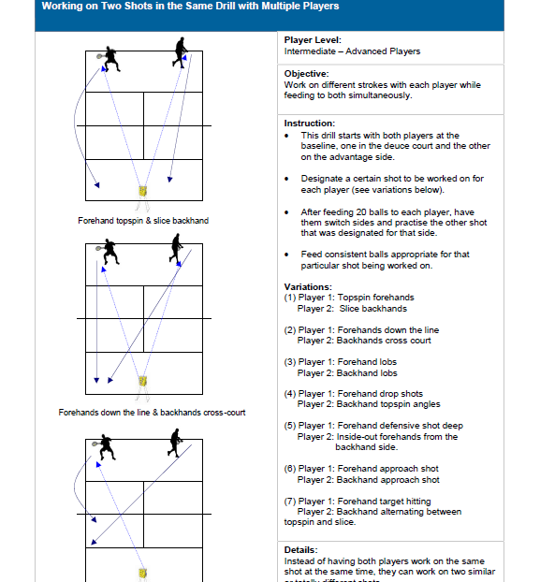  Service development  To accurately replicate an over arm tennis serve increasing power and placement. To develop decision making skills in the direction of the serve to exploit an opponent’s weakness. To understand the difference in a 1st and 2nd serve and the reasons for this. To analyse performances, identifying strengths and weaknesses of serves. | To progress this students can have a feeder in either half of the court and the returners pass one another across the opposite baseline returning shots on both the forehand and back hand side. Each time returning to a neutral stance.  Students should be encouraged to change their grip and apply top spin on both the forehand and back hand, and slice for the more able.  Differentiated practice below for the more able, below. One partner at the net or behind the baseline. Video analysis could be used to analyse the performance of the individual player, analyzing footwork, racket action and timing of the shot. If the practice breaks down, the feed could be a groundstroke from the opposite side,  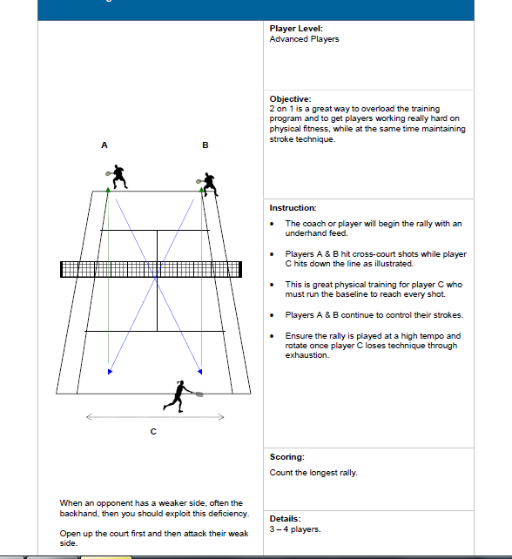
 | Lesson 3  Objectives  - To develop an understanding of the different techniques required to volley effectively in tennis  - To demonstrate some consistency and accuracy in the techniques on both the forehand and backhand  - To evaluate their performance identifying areas for improvement  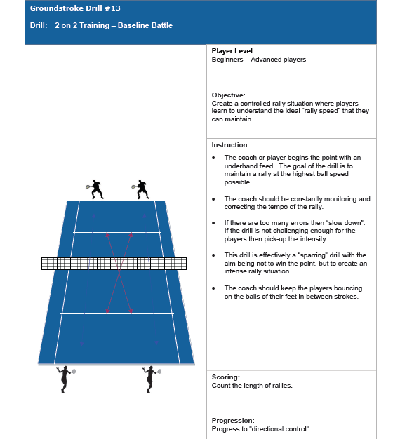  Task 3  Working in 3’s, ½ ct singles of competitive play. Students should be encouraged to get to the net to execute a volley after a deep shot. Extra marks awarded for the successful execution of the shot on either hand. The 3rd player can video a performer and feedback after the allocated time. Students should reflect on their own performance and understand what level they are working at how to improve.  At the end of the 3rd lesson, students should reflect on their progress and have a clear understanding of what NC level they are working at and how they can improve. Conversation with the teacher should confirm their understanding of their own strengths and areas for improvement. | Warm up – Recap prior learning of groundstrokes. In 3’s hand feed from the net to the base line. The returner practises both their forehand and backhand passing shots. The 3rd player retrieves the balls. Rotate every 2 minutes.  Progress to cooperative rally, with the emphasis on depth and accuracy, see diagram.  Task 1  Standing at the edge of the service box, under arm feed to your partner who is standing at the net. They are to practise the drop volley. 6 feeds on the forehand and 6 on the back hand. Look at the neutral stance, footwork & racket action. Practice this shot on the forehand, backhand, and with two hands, and from different angles so players are confident from all positions  How: When attempting a drop volley it is important that the player lets the wrist flex on contact with the ball, this ensures some of the power is soaked up by the strings, and hopefully drop the ball just over the net. There is no follow through involved in this volley as any forward movement of the racket may cause the ball to drop in the mid-back court area, and control of the point would be lost.  Points to remember: Loosen the grip just before contact is made with the ball. Try to disguise the shot as much as possible so it is not read by the opponent, giving them enough time to choose a passing winner.  http://www.teachpe.com/tennis/volleys/drop_volley.php  Task 2  The Back Hand Volley  http://www.youtube.com/watch?v=rA6QdPBXM98&feature=relmfu  How: When attempting a drop volley it is important that the player lets the wrist flex on contact with the ball, this ensures some of the power is soaked up by the strings, and hopefully drop the ball just over the net.  There is no follow through involved in this volley as any forward movement of the racket may cause the ball to drop in the mid-back court area, and control of the point would be lost.  Develop this practice this shot on the forehand, backhand, and with two hands, and from different angles so players are confident from all positions. Points to remember: Loosen the grip just before contact is made with the ball. Try to disguise the shot as much as possible so it is not read by the opponent, giving them enough time to choose a passing winner.  Demo full over arm serve. T.P’s-Start with racket behind back, split & timing. Gradually work backwards performing over arm serves to each others. Maintain timing and accuracy. Differentiation = place hoop in service box. Aim for target. (wide serve/deep serve- difficult to return) 3’s per court. Singles, 1 game king of the court. 3rd pupil to umpire.  Warm up – Student led. Agility run with cones. Pairs- time course completion. Intro lob & smash shot. Discuss when used? Type of shot? Smash-attacking, lob-recovery. Pairs; start with feed + lob to target area. Swap roles. T.P’s; angled loop. aim deep or into space on opponents side. Smash- hand as target, eye on ball. Porgress to lob & smash drill. Doubles games. 5 minute. King of the court.
 | T.Points  The ready position is crucial.  You do not have time to waste by bringing your racquet from the incorrect position. Alter the ready position slightly from the way you would prepare for groundstrokes by bringing the racquet head slightly higher. Move the elbows forward so they're just in front of the body.  As you see the ball coming move your head and hands towards the ball.This should bring the racquet head out into position in front of you.If you do this correctly you should feel your upper body go to the ball and your feet following. In emergencies this can turn into a controlled lunge or even a dive.  Do not swing the racquet at the ball, the shot should be short and punchy and take place almost entirely out in front of you. Use your wrist and forearm to bring the racquet head down on the ball in a short, sharp action. Make sure that the racquet face is slightly open. The downward action and the open racquet face should send the ball shooting through the court with a little bit of backspin. This will keep the ball low off the bounce making it more difficult for your opponent to pass you.  Follow through in the direction you want to send the ball. Then get back into the centre of the court as quick as you can ready for the next shot. Coming to the net is a very aggressive but slightly risky play. The players that excel at it are exceptionally athletic but also have an attacking gambler's mind set.  Lesson 4 Independent Learning  Objectives  - Students should demonstrate their capacity to be reflective learners and develop practices to work on weaknesses identified in previous lessons  - Students should demonstrate the capacity to work independently on their skills and create practices to promote development.  Students can be given 3 balls per ½ ct and 2 rackets and 1 video camera.  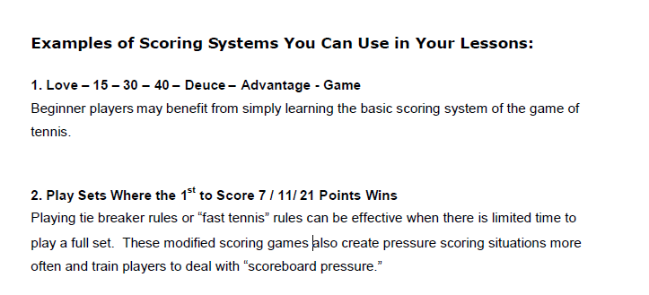  Students remain in their groups of 3, continually reflecting on their ½ ct singles to handicap competition to make it balance for all students.  Lob/smash  To accurately replicate lob & smash technique. To understand when to use a lob and the advantages it provides. To be able to apply the lob & smash in a competitive game. To encourage creative thinking in strategy development during rallies.  Drop shot  To accurately replicate the technique for a drop shot. To develop disguise on shot execution to outwit opposition. To understand when to use the drop shot in a competitive rally and how it makes your play less predictable. To be able to incorporate the drop shot to a competitive game. | The approach Volley  http://www.teachpe.com/tennis/volleys/approach_volley.php  How: Using the continental grip players are required to stop quickly as they make their way into the net to gain control of the approach volley. If a player is still running when hitting the ball it makes the volley almost impossible to control, and the ball could end up anywhere.  Having said this players should still try and step into the shot. The ball should be hit well in front of the body, the hips and knees should be low, and the head kept still.  Not much of a swing or follow through should be needed, just the opponents power from the incoming ball, to send the ball straight back over the net. Again balance and timing are crucial in hitting a successful approach volley.  After hitting this shot players should move further into the net.  Points to remember: Send the ball down the line if the player is positioned wide, or if the player is standing in the center of the court, they should play the ball back down the center to reduce passing angles.  Lesson 4  Students should create their own conditions to reward the skills that they have been working on in ½ ct games.  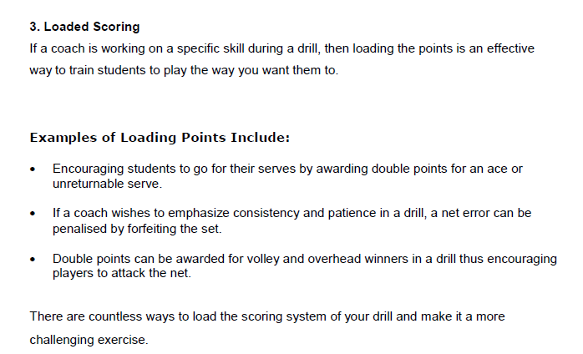  Warm up – Student led. Pairs; ½ court rally. Score points for winning shots. Discuss disguise on drop shot. Advantages/disadvantages? Pairs; ½ court each. Practice drop shots. Start from backcourt rallies. 1 partner to throw in drop shot. How to recover from drop shot. Doubles/singles games. Recap scoring; 15, 30, 40, game. Use over arm serve on 1st serve. Underarm 2nd serve optional. Pupils to umpire correctly.
6 | Examples could include;  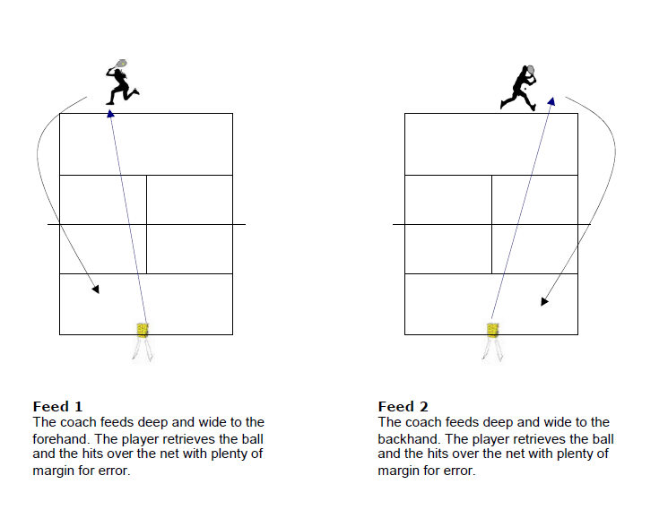  Assessment  To demonstrate the ability to outwit an opponent in a match using the appropriate skills and shot selection. The pupils are to demonstrate their knowledge and understanding of the rules in tennis. To demonstrate a variety of tactics based on the movements of others. | 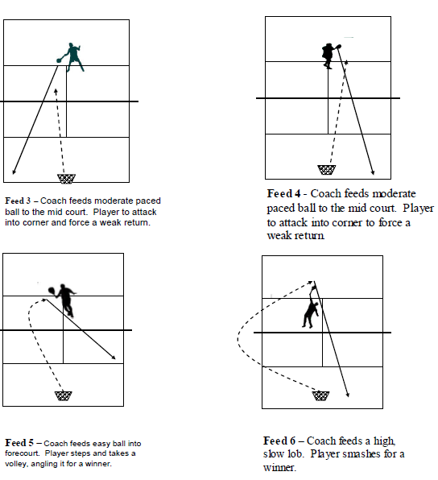  Warm up – Student led. Highlight court lines for doubles and singles. Highlight assessment criteria. Pairs to rally forehand, backhand + demo service ability. Higher levels-apply advanced shots during a rally. i.e. drop shots, lob & smash. Doubles/singles games (court depending) 5 minute games. King of the court. Winners up/losers down.  Teacher grades against NC levels
6 | Lesson 5 & 6 Introduction to doubles  Objectives  - To introduce students to the rules associated with doubles play in tennis  - To understand the different positional play in required in both attack or defense  - To devise tactics to outwit their opponent for successful performance  Doubles Tennis Serving Rotation  Serves rotate from team to team, but instead of a two player rotation (singles) a four player rotation (doubles) is noted and maintained throughout a set.  For instance, let’s say competitors A and B (Team 1) are playing a set against competitors X and Y (Team 2). Player B is serving first on Team 1 and Player X is serving first on Team 2. It has been determined that Team 2 is serving the first game in the set.  - Game 1 - Player X serves  - Game 2 - Player B serves  - Game 3 - Player Y serves  - Game 4 - Player A serves  The serve continues to rotate - X, then B, then Y, then A, then X, then B ... for the entire set. Simply put, each player rotates to serve every fourth game until the set is finalized.  In the set(s) that follow, teams can decide which player will serve first for their respective team and establish a new rotation. Strategic game play comes into play, but my advice is to let the best server on your team serve first. There is a slight addition to serving options in doubles in relation to singles.  The server gains the area behind the alley, along baseline between the singles and doubles sidelines. In other words, the server in doubles tennis can choose to serve from anywhere behind and along the baseline from the center mark to the doubles sideline on the team's end of the court.  The Doubles Tennis Tie-Breaker  Basically, singlestie-breaker scoring and guidelines are maintained in the doubles tie-breaker, but there is an exception. Similar to singles, the two-point rotation starts after the initial point is played out and the serving rotation is maintain  The difference is that instead of two, there are four players participating in the two-point serving rotation. For example, let’s say competitors A and B (Team 1) are playing a tiebreaker against competitors X and Y (Team 2). The serving rotation is maintained above and Player X next in line to serve.  Assessment  To demonstrate the ability to outwit an opponent in a match using the appropriate skills and shot selection. The pupils are to demonstrate their knowledge and understanding of the rules in tennis. To demonstrate a variety of tactics based on the movements of others. | Warm up – Student led. Highlight court lines for doubles and singles. i/2 ct cooperative rally to practise their repertoire of shots.  This rotation continues until a team wins the tie-breaker. To win the tie-breaker and finalize the set, a team must score a minimum seven points combined with a two point advantage. Possible tie-breaker scoring results for the winning team could be 7-1, 7-5, 8-6, 14-12, 21-19, etc.  - Point 1 - Player X Serves  - Point 2 - Player A Serves  - Point 3 - Player A Serves  - Point 4 - Player Y Serves  - Point 5 - Player Y Serves  - Point 6 - Player B Serves  - Point 7 - Player B Serves  - Point 8 - Player X Serves  - Point 9 - Player X Serves  There are three basic court positions for doubles tennis: two up, two back and one up, one back.  Two Up  Two up means that both players are positioned at the net. This is the best of the three because you are offensive and can cover most of the court from this configuration.  The one wild card is the lob. Because there is nobody there to back you up. You must learn to recognize the lob earlier by watching the opponent’s court position and racket face. For example, if you've come in behind a deep approach shot or hit a deep first volley and you see your opponent back up, odds are you will see a lob. Anticipation is the key to covering the lob effectively.  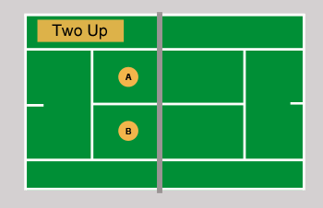
6 | Two Back  Two back means that both players are positioned on the baseline. Although most of the court is covered and you do not have to worry about the lob, this is not considered as effective as two up because it is difficult to be offensive from the baseline in doubles.  This configuration should be used if you are and your partner are not good volleyers, or at times when your opponents are moving a lot at the net and outplaying you from there.  Then the best bet is to step back to make it more difficult for them to hit winners and to make sure you don’t go home with a bunch of bumps and bruises courtesy of the other team drilling you with the ball.  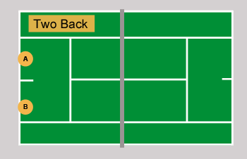  Conditioned games  Task 1 – Both groups adopt baseline play. Their aim to outwit their opponents through effective, consistent and accurate shot selection & execution.  Task 2 – 1 group play 3 games where they try to play 2 up and execute the volley to kill the point off. Shot selection for the baseline team now is crucial, and Q&A opportunities should encourage students to reflect on their practice. Rotate roles.  Task 3 – 1 up & 1 down. Students are to experience this formation and discuss the advantages and disadvantages.  Task 4 – Open play. Students select the tactics as and when the game dictates. Ensure correct application of the service rules and scoring system are used.  Ladders tournament over the final lesson to ensure healthy and balanced competition is achieved. | One Up - One Back  One up, one back means that one player is standing at the net while their teammate is on the baseline. This is the least desirable of the three configurations mainly because there is a big gap left open in the court right down the middle.  As long as the ball stays in front of the player at the net, it is not as big a problem. But if the pattern switches and the ball is cross-court from the net player, then you are in trouble.  It also makes poaching (the opponents net player crossing the middle of the court to intercept the ball) more effective because there is a big open target to hit to when the opponent gets the ball.  Many times you will find yourself caught in a one up, one back situation. Don't panic, it's not the end of the world. But do try to get up to the net with your partner at the earliest opportunity to be more aggressive.  If you don’t feel comfortable doing this because of the level of your volleys, then work on your volleys until you do feel comfortable. You will also find that the more often you move forward to the net, the easier it will become to see the lob coming before your opponent even makes contact with the ball.  http://www.active.com/tennis/Articles/How-to-Win-at-Doubles-Against-All-Odds.htm  